USE OF BACTERIOPHAGES TO TREAT MULTIDRUG-RESISTANT
STAPHLOCOCCUS AUREUS
By
CHANDLAR A. GLOVER

A Thesis submitted in Partial Fulfillment of the Requirements for the Degree of Master of Science in the Department of Biotechnology
Claflin University
Orangeburg, South Carolina
May 2023
__________________________ ______________________________
Dr. Omar Bagasra Dr. Randall Harris
Thesis Advisor Committee Member

________________________ _____________________________
Committee Member Dr. Omar Bagasra
Srikant Pawar Academic Advisor

Received by:________________________________________________ Date: ______
Dr. Gloria McCutcheon, Chair, Department of Biology
Received by:_______________________________________________ Date: ______
Dr. Verlie Tisdale, Interim Dean, School of Natural Sciences and Mathematics
Received by:_______________________________________________ Date: ______
Dr. Verlie Tisdale, Interim Vice Provost for Academic Programs

ACKNOWLEDGEMENTS

I would like to thank Dr. Bagasra for allowing me to conduct research under his guidance, I am genuinely grateful. I would also like to thank my committee members for their time, effort, and knowledge in helping me succeed in my studies. Their vast wisdom and wealth of experience has inspired me throughout my matriculation at Claflin University. I would like to express my sincere gratitude to everyone in the Biotechnology Department. Thanks to each faculty and staff member for their encouragement and belief in me. The time spent studying and conducting research has been truly rewarding. I would like to thank my family. Their love, guidance, and understanding has kept me going. My family has motivated me and never allowed me to falter.
Last, but certainly not least, I would like to thank God and for being my everything. Because, He has ordered my steps; I will continue to move forward.

THESIS STATEMENT

The rise of multidrug-resistant bacteria has generated a great challenge to treat infections caused by bacteria with the available antibiotics. Among the list are various Gram-positive bacteria that are responsible for serious healthcare and community-associated infections. Methicillin-resistant Staphylococcus aureus (MRSA), vancomycin-resistant Enterococcus faecium, and drug-resistant Streptococcus pneumoniae are of particular concern. Antimicrobial resistance demands continuous efforts to create strategies to combat this problem and optimize the use of antibiotics. The aim of the present research is to identify bacteriophages that can kill four different strains of MRSA.

ABSTRACT

BIOTECHNOLOGY
CHANDLAR A GLOVER M.S CLAFLIN UNIVERSITY, 2023

USE OF BACTERIOPHAGES TO TREAT METHICILLIN -RESISTANT STAHLOCOCUS AURUES (MRSA)
Thesis Advisor: Dr. Omar Bagasra

Thesis Dated: MAY 2023

Staphylococcus is a genus of the Gram-positive cocci family Staphylococcaceae. S. aureus is a major human pathogen associated with high infection and mortality rates and is one of the leading causes of minor and life-threatening diseases like infections of the respiratory tract, skin and soft tissue, pleuro-pulmonary, device-related infections, and infective endocarditis.
Good susceptibility to S. aureus led to the discovery of penicillin by Alexander Fleming. Penicillin resistance was developed just a few years after its introduction into the clinical practice and within a decade it became a significant problem in the community. S. aureus has an extraordinary ability to acquire resistance to any antibiotic. Penicillin-resistant S. aureus produced a plasmid-encoded penicillinase that hydrolyzes the β-lactam ring of penicillin which is essential for its antimicrobial activity.

Staphylococcus Aureus—Methicillin-Resistant
In 1959, methicillin semisynthetic penicillin was developed to counteract a bacterial resistance mechanism, but in 1961 the first methicillin-resistant S. aureus or MRSA was identified in the United Kingdom and was found to be resistant to all β-lactam antibiotics including cephalosporins and carbapenems. Methicillin-resistant Staphylococcus aureus (MRSA) outbreaks led to its classification into two types: (1) healthcare-associated MRSA (HA-MRSA) in which patients exposes to MRSA strains due to hospitalization, surgery, hemodialysis, etc., and is typically resistant to clindamycin, and (2) community-associated MRSA (CA-MRSA) is described as strains that can infect healthy people that have no contact with healthcare facilities, and they are susceptible to clindamycin and none β-lactam antibiotics .
The goal of my research was to isolated bacteriophages isolated from the Orangeburg sewer system and from the nearby soil that exhibit anti-MRSA effects. Four strains of highly methicillin-resistant MRSA were obtained from the Tristate Regional Medical Center located in Orangeburg, SC. These four strains were characterized by the microbiology department of the hospital and were resistant to methicillin. I isolated bacteriophage from 28 water and soil samples and isolated bacteriophages that lysed all four MRSA strains.

KEYWORDS AND ABBREVIATIONS

Keywords: Phage, Bacteriophage, Phage therapy, Bacteriophage therapy, Antibiotic resistance, Multidrug resistance, methicillin resistant bacteria.
Abbreviations
MRSA- methicillin-resistant bacteria
S. aureus - Staphylococcus aureus

TABLE OF CONTENTS
ACKNOWLEDGEMENTS
THESIS STATEMENT………………………………………………………………………3
ABSTRACT.…………………………………………………………………………………4
KEYWORDS AND ABBREVIATIONS……………………………………………………5
INTRODUCTION……………………………………………………………………………7
BACKGROUND AND LITERATURE REVIEW……………………………………………………………………………………8-9
MATERIALS AND METHODS………………………………………………………………………………… 10
ISOLATION AND PREPARATION OF BACTERIOPHAGES…………………………………………..………………………… 11
LIFE CYCLE AND MORPHOLOGY OF A PHAGE……………………………………………………………………………………22
SUMMARY AND CONCLUSION………………………………………………………………………… 26
REFERENCES…………………………………………………………………………27-30

INTRODUCTION

Use bacteriophages for therapeutic purposes against bacterial infections to combat multidrug-resistance bacteria has been used worldwide for almost a century. There has been controversy regarding the initial observations on the phage's biological nature, phage-induced bacterial lysis and phage therapeutic value. Frederick Twort first described the characteristic zone lysis connected with phage infection in 1915. Felix d’Herelle identified the phenomenon source and attributed such plaques to the bacterial viruses and termed them bacteriophages, which meant 'bacteria-eater' (1). Also, d’Herelle forwarded the concept of using phages for therapeutic purposes; he is responsible for the first documentation of the clinical application of phages in Paris at the hospital des Enfants-Malades in 1919 (2-4).
Staphylococcus aureus was first identified and described in 1880 by Alexander Ogston, a surgeon who isolated the bac- terium from a surgical abscess [5]. S. aureus is a Gram-pos- itive bacterium and facultative anaerobe with low genomic G + C content. It is a common commensal of humans and animals and may be found colonizing nares, axilla, peri- neum, skin, and multiple other body sites; however, nasal carriage is of greater concern because it is the most common source of MRSA for disease spread [6-7]. It is estimated that approximately 15% of the population persistently carry S. aureus in the anterior nares; some populations have higher rates of S. aureus colonization including health care workers and hospitalized patients [4]. People harboring this bacte- rium are at greater risk of developing S. aureus infections.
In the 1990s, after the introduction of ciprofloxacin, resistance to fluoroquinolones emerged rapidly in S. aureus, especially in MRSA. Resistance developed due to mutation in the genes encoding target enzymes that are essential for DNA replication (mutation in subunit gyrB of DNA gyrase and subunit grIA of Topoisomerase IV) and due to changes in drug entry and overexpression of an efflux pump NorA [9].
In humans, S. aureus can infect most organs and is a leading cause of death by infection [6]. It is one of the major causes of morbidity and mortality in hospitals in part because it can produce biofilms on indwelling devices such as catheters and medical implants, from which bacterial cells may detach resulting in secondary and disseminated infec- tions [.]. S. aureus is one of the most successful pathogens due to the vast arsenal of virulence factors, including anchor proteins, secreted toxins and enzymes, polysaccharides, and immune system modulators. These are often located on mobile genetic elements (MGEs), which help diversify the virulence and resistance genes via horizontal gene trans- fer. Methicillin, a semi-synthetic β-lactam antibiotic, was first applied to treat S. aureus infections, but the bacterium soon developed resistance and became known as methicillin- resistant S. aureus (MRSA). Several reports have described vancomycin-resistant S. aureus (VRSA) and vancomycin-intermediate S. aureus (VISA); however, vancomycin remains in the list of first choice antibiotics for treating S. aureus severe infections [12]. The World Health Organization (WHO) has identified several bacterial pathogens, including MRSA, as leading causes of nosocomial infections; these infections are mainly caused by inappropriate and irrational use of antimicrobials/antibiotics in the healthcare facili- ties and food industries. In 2015, the WHO introduced an action plan against antimicrobial resistance, wherein one of the important focal points was the development of novel antimicrobials products to combat MDRs (13).
S. aureus has the ability to rapidly develop resistance to nearly any antibiotic drug coming into clinical use [14]. Studies on S. aureus have intrigued researchers worldwide, especially with regard to its evolution, as some types and subtypes of MRSA emerged and spread globally. MRSA is a major threat both in healthcare and outside healthcare settings (i.e., in communities).
In my present research I describe the effectiveness of phages and phage proteins against this important nosocomial pathogen.

BACKGROUND AND LITERATURE REVIEW

In human treatment, '' cocktail" of numerous phages may decrease the likelihood of choosing microbes that created resistance from a specific phage. For a long time, starting with penicillin, anti-infection agents changed medication entirely stopping a global spread such as the Black Plague. Already, nine years prior, more than 20,000 yearly deaths in the United States were attributed to the absence of successful antibiosis. Development and authorizing of new antibacterial agents require quite a while, which is unsatisfactory in this worldwide disaster. It is very important to search for new compounds, however quick resistance from new medications is unsurprising. These two facts need an adjusted permitting pathway requiring a committed production and refinement process including chromatography, filtration, and other techniques. An article distributed not long ago in a German clinical journal expressed that MRSA prevalence has been steady for years, while the VRE pervasiveness expanded by six-fold. Both are on the WHO need list for high need of action. If the skin is harmed, our own microbial inhabitants can attack, colonize, and cause infection. A review was performed in 2008 to 2010 with 153 patients, no undesirable immunity reaction could be depicted; phage adequacy appears to be self-sufficient of immune reaction. Georgian specialists are applying for the most part complex cocktails made by Eliava Biopreparations, despite the fact where they don't work. Both are examined and improved like clockwork, with phages added that target new complicated bacteria, and are generally accessible in Georgian pharmacies.
Antimicrobial resistance is a significant general medical issue that may cause an expected 10 million deaths each year by 2050. Phages are nature's most plentiful bacterial killer. They can be utilized alone or merged with anti-microbials against challenging to-treat infections. Phage treatment has been utilized since the 1920s in the former Soviet Union and is still presently utilized in ex-Soviet nations like Poland, Russia, and Georgia. Phage treatment is now being returned to as a likely option in contrast to anti-toxins in Western countries. Bacteria can oppose phage strikes through various components, including unconstrained mutations, confined modification systems, and adaptive immunity by the use of the CRISPR-Cas system. Unconstrained mutations are the primary tool for both phage resistance and phage-bacterial coevolution. Unconstrained changes might present phage resistance by altering the design of bacterial surface components that restrict phage receptors entry by altering receptors. Phage-resistant variations have also been observed and in one out of four phage there is development of resistant to phages by receptor modification phage resistance. Ongoing animal studies have documented bacterial resistant to phage resulting in adverse effects on the animal host.
Antibiotics have become less effective as the prevalence of antibiotic resistant to bacteria, for example, methicillin-resistant Staphylococcus aureus (MRSA), has expanded, and immunocompromised patients are particularly defenseless against MRSA and other MDs. Besides, antimicrobial agents with new methods of action are turning out to be less inclined to be created, because the vicious cycle that arise by the utilization of new antibiotics and the importance of drug-resistant bacteria lessen commercial interest in the advancement of new antibiotics. The bacterial growth was significantly lower in the phage-treated group than in the control group 24 hours after the infection.
Staphylococcus aureus is highly adoptable microorganism and can be commensal and can remain in human skin surface or in internal parts of a human without causing any disease. However, it can also cause skin abscesses, serious wound infections, pneumonia, endocarditis, bone infection pneumonia and toxic shock syndrome. One of the more serious problems with S. aureus is the development of MRSA strain that are resistant to numerous antibacterials. Furthermore, it may also adapt to survive inside cells, where it is protected from antimicrobials and host defense mechanisms including antibodies and cellular immune responses. In the study carried out by Capparelli et al., where they utilized bacteriophage active against MRSA to evaluate the effects of bacteriophage in mice model by with the lethal dose of 10⁸ CFU of MRSA and treated it with 10⁹ PFU of phages. 97% of the mice survived the infection. When mice were infected with nonlethal dose of MRSA and treated with bacteriophage resulted in 100% survival. In addition, they delivered bacteriophage via macrophages to target intracellular MRSA in vivo and in vitro, both resulted in elimination of MRSA intracellularly. This form of therapy can be used to treated abscesses where antibiotics do not reach at a sufficient concentration.
In this study, rats were given intravenous phage therapy to treat ventilator-associated pneumonia (VAP) caused by methicillin-resistant Staphylococcus aureus (MRSA). Prazak et al., compared intravenous teicoplanin to a combination of four phages in a randomized, blinded, controlled experimental research. At Day 4, the primary result was survival. Bacterial and phage densities in the lungs and spleen, histological scoring of infection in the lungs, and inflammatory biomarkers in the blood were all secondary outcomes. Treatment with phages or teicoplanin boosted survival rates from 0% to 58 percent and 50%, respectively. The use of both phages and antibiotics had no effect on the results (45 percent survival). In the VAP model, male Wistar rats at 9-10 weeks old were housed pathogen free rooms in light/dull condition, with water as well as food was given. Animal survival was linked to lower bacterial loads in non-surviving lung animals. In terms of improving survival and lowering bacterial load, phage therapy was just as effective as teicoplanin. In rats afflicted with methicillin-resistant S. aureus, phage therapy was just as effective as teicoplanin in enhancing survival and lowering bacterial burden in the lungs. Antibiotics and phage therapy were not combined to improve outcomes. High bacterial loads in the lungs were linked to mortality. Those who died from infection had 1,000 times more MRSA in their lungs than those who lived. Phages were similarly successful at controlling bacterial loads in the lungs of infected rats as teicoplanin, and the combination of phages and antibiotics did not lower lung bacterial burdens any further.
Staphylococcus aureus (SA) has arisen as a significant general wellbeing danger because of the organisms propensity to create resistance against antibodies. The Staphylococcus species, having a huge number of elements that upgraded the host-adhesion, eluding the human natural defense, and cytolytic movement against host cells. The objective is to determine popularity, administer, an in vitro resistance patterns of MRSA keratitis isolated compared to methicillin-susceptible SA (MSSA) keratitis to set apart the commonly used ophthalmic is twenty-year retroactive review. The methods used (Chang e tal, 2016) was evaluated the antibiotic sensitivity testing of the separation of SA. Low degrees of in vitro obstruction against agent of infective do not essentially relate with poor clinical adequacy. anti-infection fixations are a lot higher in visual tissue by means of effective treatment in correlation of systematic treatment. Systematic qualifications are most likely to be overvalued due to laboratory resistance measurements. The 398 SA detaches were additionally partitioned into two classifications: MSSA and MRSA. There were an overall of 122 MRSA disengages that showed 30.7% (122 out of 398) of the entire SA confined and 7.7% (122 0f 1576) of the number of microscopic organisms separated. Information upholds the theory that MRSA and MSSA vary in their resistance design. MRSA secludes have significantly expanded protection from all examined anti-infection agents in contrast with MSSA, except for polymyxin B and vancomycin.
Antibiotic resistance is a huge issue related with orthopedic implant infections. Bacteriophages are viruses that contain over1030 known phage types, they are the most bountiful organic particles on the earth and found wherever microorganisms reside. Phage replication inside the selected host bacterium and lyse the host. Phages have emerged as powerful potential antibacterial factor, particularly against multidrug-resistant microorganisms. Many bacteriophages display a simply lytic lifecycle, yet a few bacteriophages do not quickly kill the bacterial host. These bacteriophages integrate into the host DNA genome and go dormant, reactivating and reentering into lytic phase. Temperate bacteriophages also give immunity from additional infection from related bacteriophages and add to even quality gene exchange that can prompt the spread of antibiotic resistance and toxins. Animal experiments concentrates on zeroing in on bacteriophage treatment for bone and joint infections with absence. Only one bunny, one rodent, and four mice review have been published. Bacterial infection resistance to various antibiotics agents addresses one of the serious issues of orthopedic procedure, Yilmaz et al tried the hypothesis that use of bacteriophages would be powerful therapeutic tool against biofilm-forming bacteria. The possible therapy of MRSA to prevent osteomyelitis was tried in a rabbit model. In this experiment they utilized a rabbit model of chronic osteomyelitis in the distal end of rabbit femoral bone and administered a "cocktail" of seven bacteriophages. They compared the” treated” vs “untreated” animals and concluded that of the untreated animals suffered from sclerosis and osteolysis of the bones, sequestrum development, and other sequelae like joint pain of the knee, whereas treated animals groups suffered none of these maladies. The treated animals recuperated from osteomyelitis inside about fourteen days of after phage. Treatment and recovery were joined by enhancements in the appetite and lessened residential oedema, erythema, and induration.
The production of phage neutralizing antibodies is a key problem during phage therapy. The goal of this study was to demonstrate the efficacy of phage therapy in a clinically relevant rabbit model of Staphylococcus aureus-caused fracture-related infection. This study shows that phage therapy works in a clinically relevant rabbit model of Staphylococcus aureus-caused fracture-related infection (FRI). Fracture fixation devices have had a huge impact on patient care, resulting in shorter hospital stays and a faster return to function. However, one significant disadvantage of this technical advancement is the possibility of contracting device-related illnesses. They were group housed with a 12-hour dark –12-hour light cycle and fed hay, lettuce, and rabbit supplemental feed during this time. With an aim of eight rabbits per group, test groups got either phage in saline or no therapy. The capacity of phage therapy to support conventional antibiotic therapy of an established infection was tested in the second phase of this trial. Antibiotics only, phage in saline with contemporaneous antibiotic therapy, phage loaded hydrogel with concomitant antibiotic therapy, and antibiotics in saline with concomitant antibiotic therapy were the treatment groups. In this experiment, 42 animals were used. Due to unclear causes, two rabbits died during the induction of anesthesia for the index procedure. Two of the animals in the therapy research were culture-negative at revision surgery, making it difficult to assess the impact of the intervention on the infection. They were euthanized as a result. The prevention and treatment trial's group allocation and study design are described. On the next to last study day, one animal died overnight and was discovered dead in its cage. It was kept in the study. Due to acute diarrhea, three animals were executed one day before their scheduled euthanasia and were kept in the study population. In both the phage-treated and control groups, white blood cell (WBC) counts were within normal limits.

MATERIALS AND METHODS

Collection of water and soil samples from the Orangeburg area
Twenty-eight water and soil samples were collected in sterile 50-mL tubes from various areas around the Orangeburg including Edisto River, Spring Water and lakes including Ginger Lake and Donkey Lake. Two samples were collected from Aiken and Kingstree area. Each of the water samples were first centrifuged to precipitate the debris and then they were filtered with 0.22-micron Amicon filters. The soil samples were first mixed with sterile water, shaken vigorously and then centrifuged and filtered with 0.22 micron filtered. All the samples were pooled for to conduct the experiments.

Bacterial culture of a known MRD S. aureus was streaked on Luria-Bertans (LB) agar (Sigma Co.-USA), and after 48 hours, individual colonies were picked, and their purity were determined by Gram- staining, morphological characteristics, and specific biochemical analyses (Figure 1-4).

Determination of Minimal Inhibitory Concentrations (MIC)
The MDRs microbe’s antibiotic plates were prepared by adding the following antibiotics At final concentrations of 5-200 μg/ml from the stock solutions of Ciproflaxin, Nalidixic Acid, Ampicilin, Gentamycin, Methicillin, Vancomycin and Mitomycin in sterilized LB agar. The purified S. aureus were re-plated to verify the purity of culture. Minimum inhibitory concentration (MIC) of various colonies of this MDRs strain was done by standard MIC method in the Local (TRMC Hospital, Department of Microbiology) prior to its donation to Dr. Bagasra’s lab.

Plaque assay by double layer method: 100 μl of early exponential phase bacterial culture and 50 μl of respective lysates were mixed with CaCl₂ and MgSO₄ (0.1 M final concentrations) into 3 ml of melted LB soft agar tube. It was then poured on LB agar plate and incubated at 37°C overnight. Negative control contained no lysates.
Serial Dilutions of Bacteriophage lysates to isolate S. aureus MRD specific bacteriophages: Serial 1:10 dilutions of lytic bacteriophages were carried to determine the single phages that specifically targeted MDR S. aureus. I carried out dilutions from 1:10 to 10-20 in order to isolate the single phages. Each of the single phage were further amplified by co-culturing each of them in exponential MDR S. aureus cultures. These cultures were centrifuged, and the supernatants were stored at 4 C for further analyses and phage typing.

Isolation and purification of MDR microbes
Bacterial cultures of the four strains of MRSA were obtained from a local hospital (clinical isolates and Lab collection). The specimens were streaked on Luria Bertani (LB) agar (Sigma Co.-USA), and after 48 hours, individual colonies were picked and their purity were determined by Gram-staining, and morphological characteristics.

Determination of Minimal Inhibitory Concentrations (MIC). The MRSA microbe's antibiotic plates were prepared by adding the following antibiotics at final concentrations of 5-200 g/ml from the stock solutions of Ciproflaxin, Nalidixie Acid, Ampicilin, Gentamycin, Methicillin. Vancomycin and Minomyein in sterilized LB agar (Hardy Diagnostics). The purified S. aureus were re-plated to verify the purity of culture. Minimum inhibitory concentration (MIC) of various colonies of this MRSA strain was done by standard MIC method

Isolation and purification of bacteriophage. Phages were isolated from local sewer water and soil samples from Orangeburg County.

Phage isolation, purification, and quantifications. Phages were purified by successive single plaque and propagation method. Briefly, a single plaque was picked from a plate using a sterile capillary tube and added to a mid-log-phase S. aureus MRSA culture (10° CFU/ml) supplemented with 0.1M CaCl₂, 10 ml of culture mixture and phage mixture were incubated at 37°C overnight. The lysate was filtered through a 0.22 mm-pore-size sterile filter (EMD Millipore Co.). For quantification and titration, serial dilutions of the phage containing filtrates were made, and plaques were allowed to develop on a lawn of the same host bacterial culture. Single plaques were purified through 3 successive rounds of plaquing and repeated three additional times, after which purified phages were obtained. All lysates were stored at 4°C.
In order to isolate individual phages responsible for MRD lysis the samples were serially diluted up to 10¹⁹. The dilution method is shown below in the Figure below.
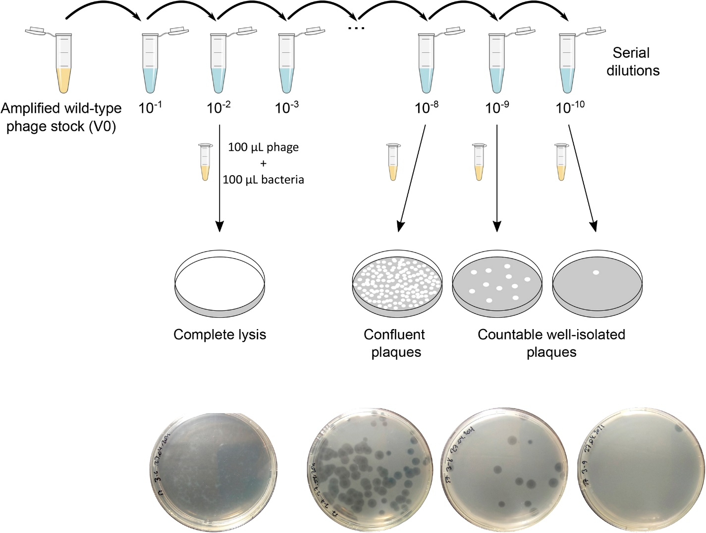

Determination of phage interaction with bacteria:
Plaque assay by double layer method: 100 ml of early exponential phase bacterial culture and 50 ml of respective lysates was mixed with CaCl₂, and MgSO₄, (0.1 M final concentrations) into 3 ml of melted LB soft agar tube. It was then poured on LB agar plate and incubated at 37°C overnight. Negative control contained no lysates (shown in Figures 8-16 in the result section).
﻿﻿﻿Spot assay by double agar layer method: 100 ml of the early exponential phase culture of bacterial culture was mixed into 3 ml of melted LB soft agar and plated on a LB agar plate. After solidification, 10 ml of phage lysate was applied on the bacterial lawn and incubated at 37°C, overnight.
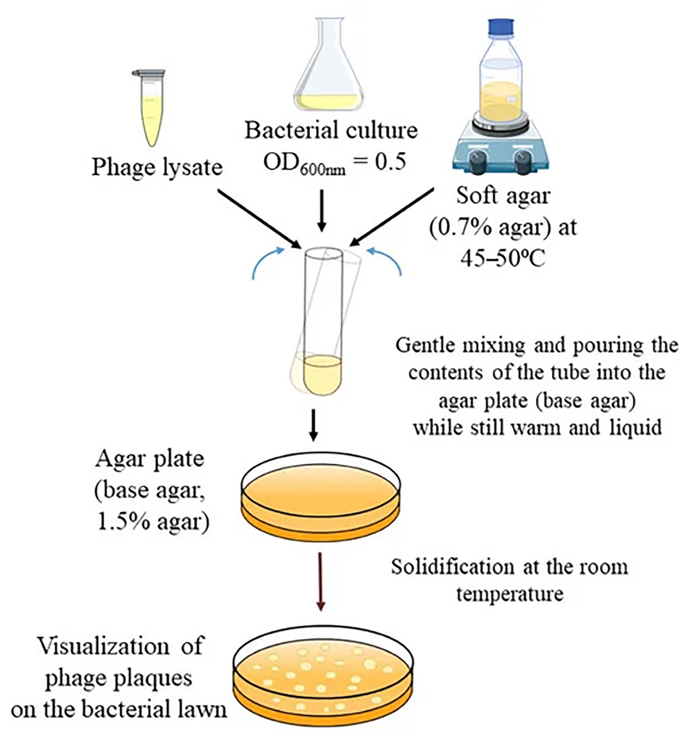

Spot assay by double agar layer method: 100 ml of the early exponential phase culture of bacterial culture was mixed into 3 ml of melted LB soft agar and plated on a LB agar plate. After solidification, 10 ml of phage lysate was applied on the bacterial lawn and incubated at 37°C, overnight.

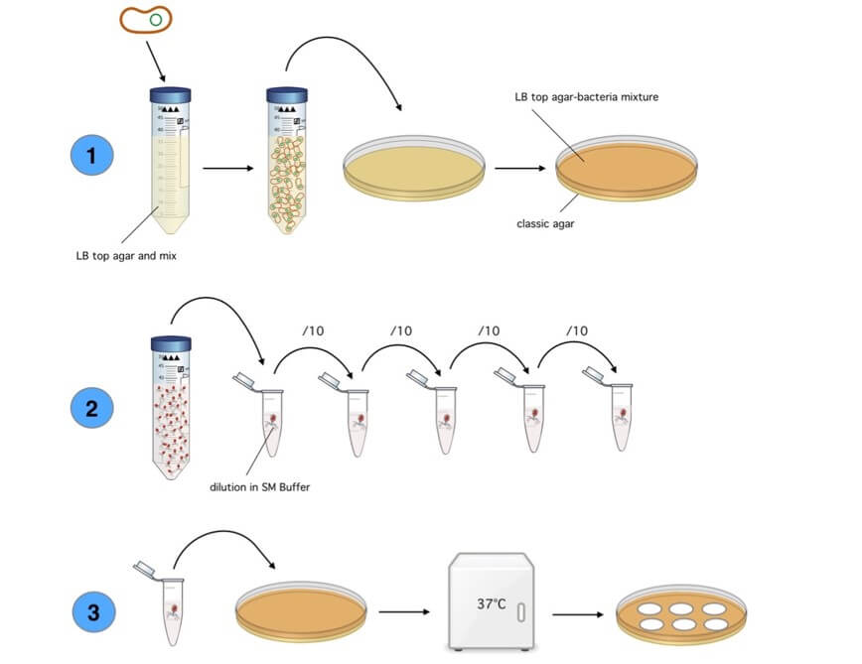

RESULTS
Single Cell Colony Isolation of four MRSA strains
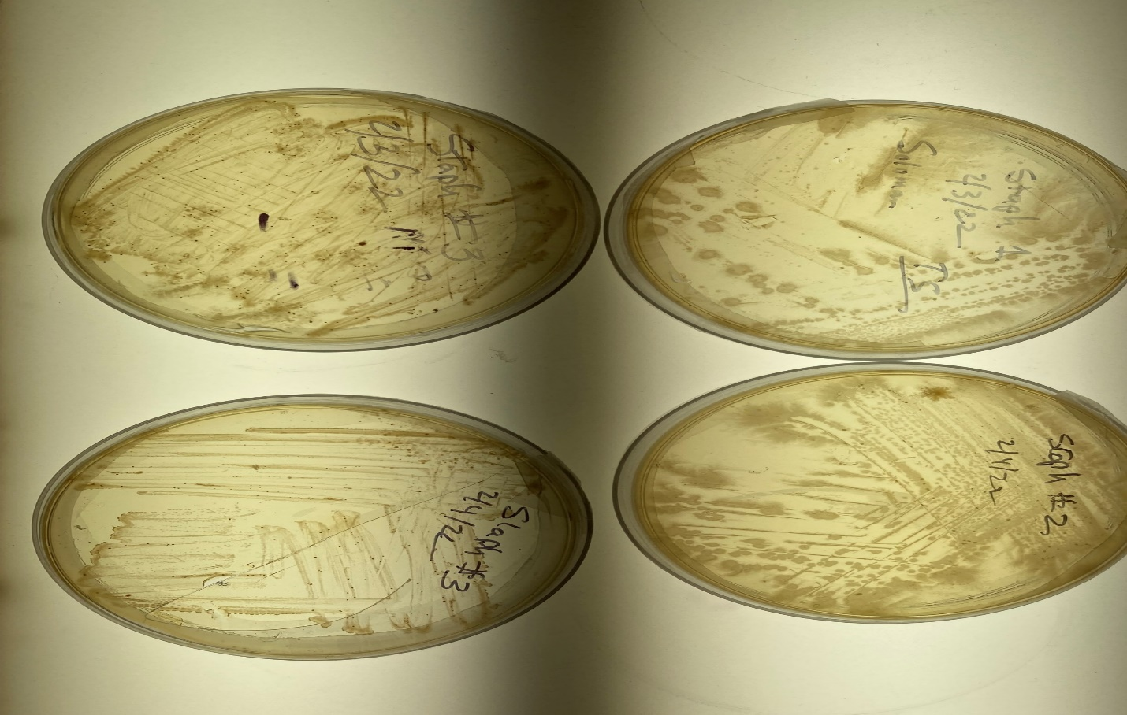
Figure 1: In order to isolate single colony from each of the MRSA each of the MRSA were streaked on LB agar and then single colonies were picked to grow each of the colony in LB broth.

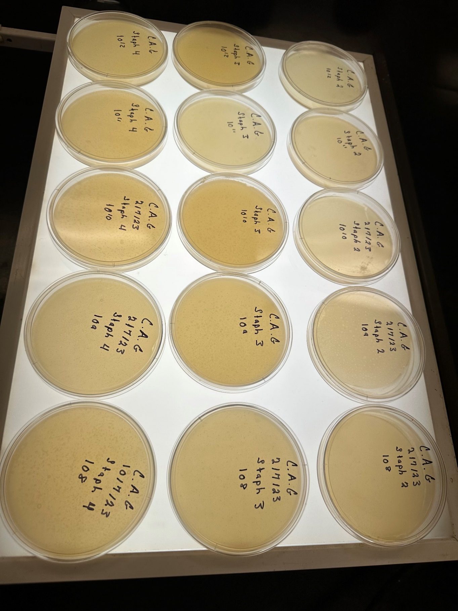
Figure 1: Results of experiment with four MRSA strains showing a large number of plaques at 10⁸ dilution of lysate.

Isolation of bacteriophages by dilution method: The lysates from the single cell colony MRSA were mixed with various dilutions of phage lysates and mixed with each of the MRSA cultures and plated on top of the bottom layer and the development of plaques were observed. The figures below exhibit plaques formations at 10⁻¹¹ dilution.

Plaques at 10^11 Dilution
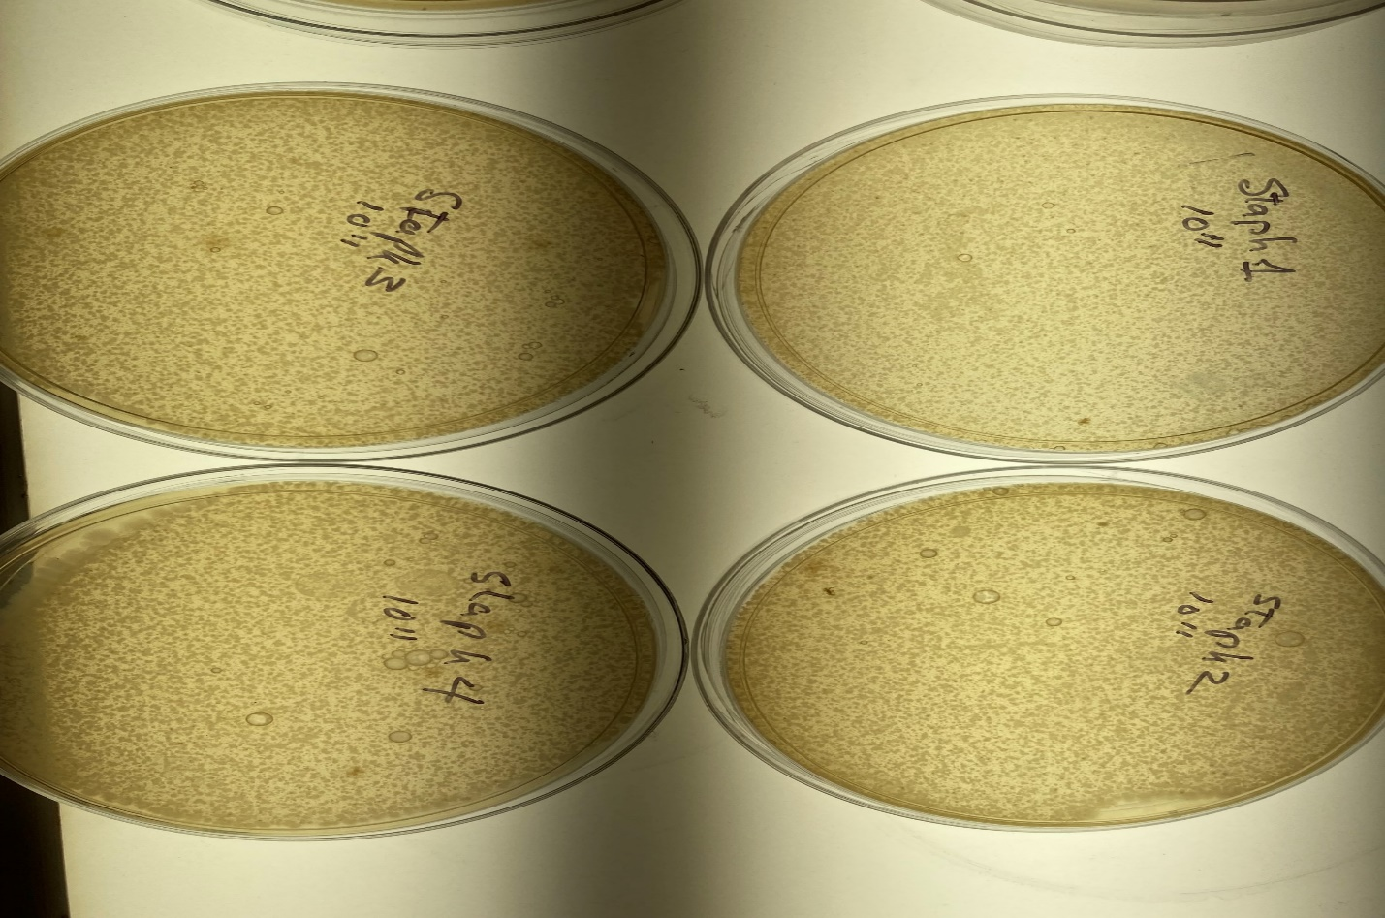
Plaques at 10^13 Dilution
Plaques at 10^11 Dilution

At 10¹¹ dilutions the number of plaques were too many to count as shown below.
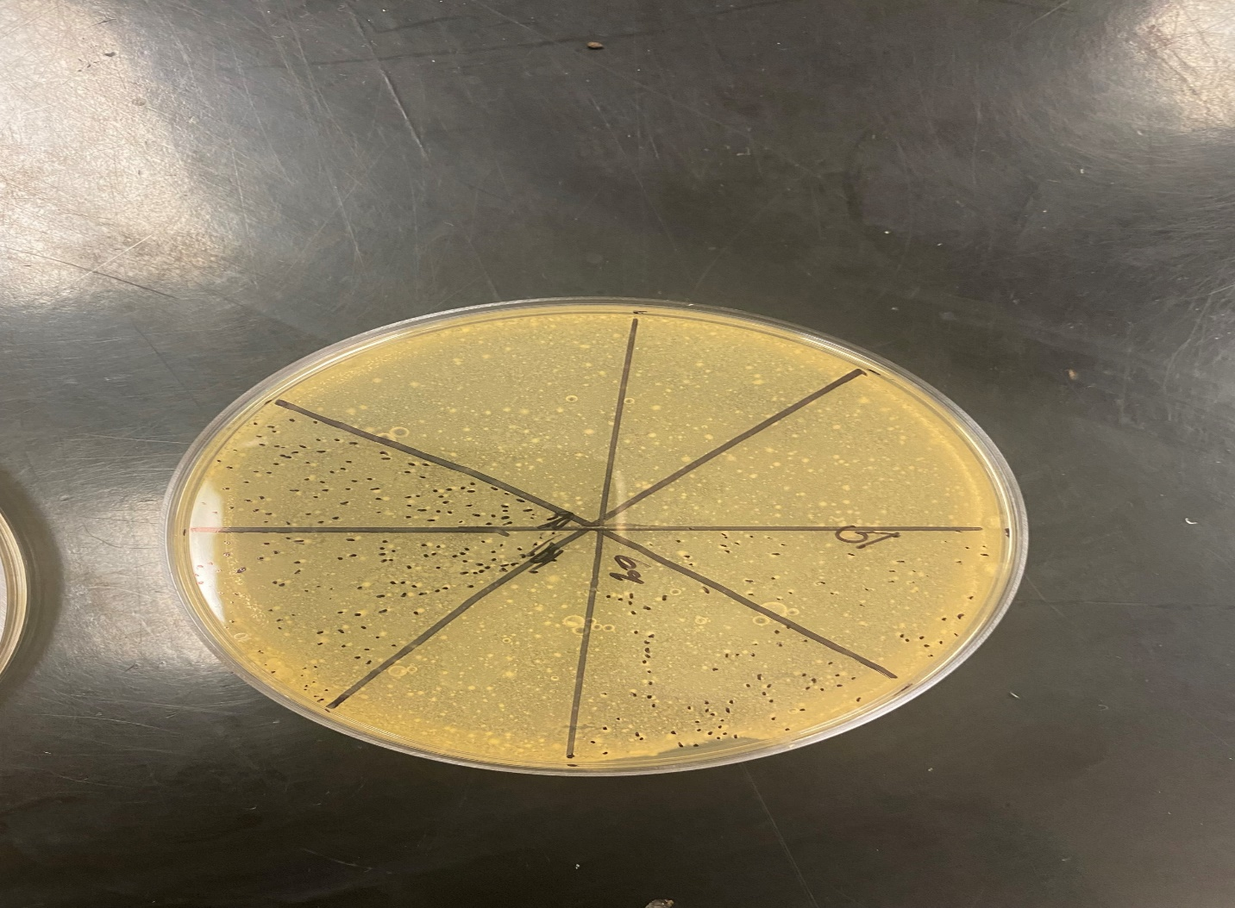

Further dilutions were necessary to isolate single bacteriophages against each other the MRSA strain.

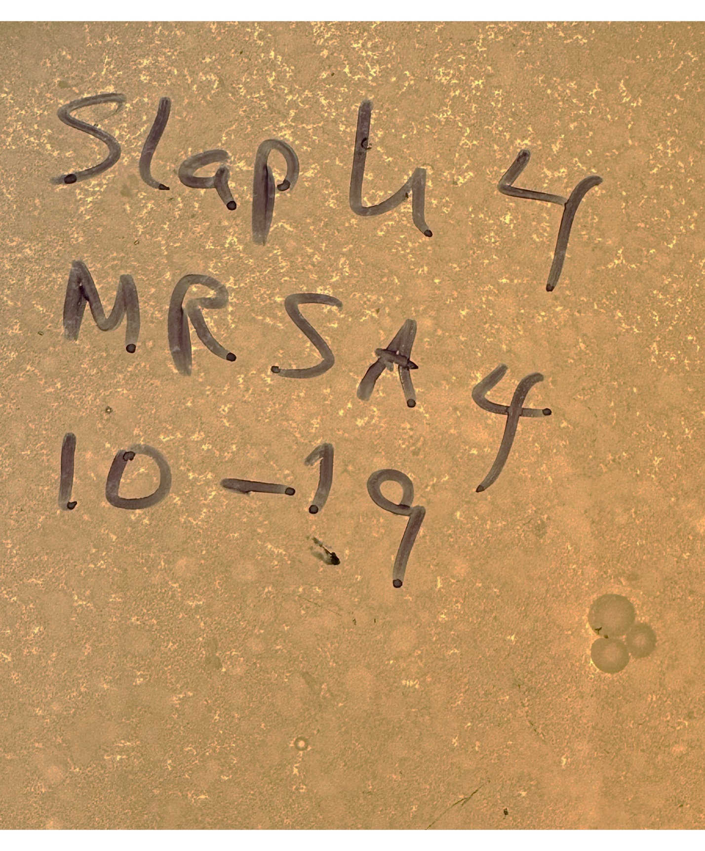

The above figure shows individual bacteriophages at 1019 dilution for MRSA #4.

The figure below shows individual colony formation at 10-22 dilution. The arrow shows a phage.
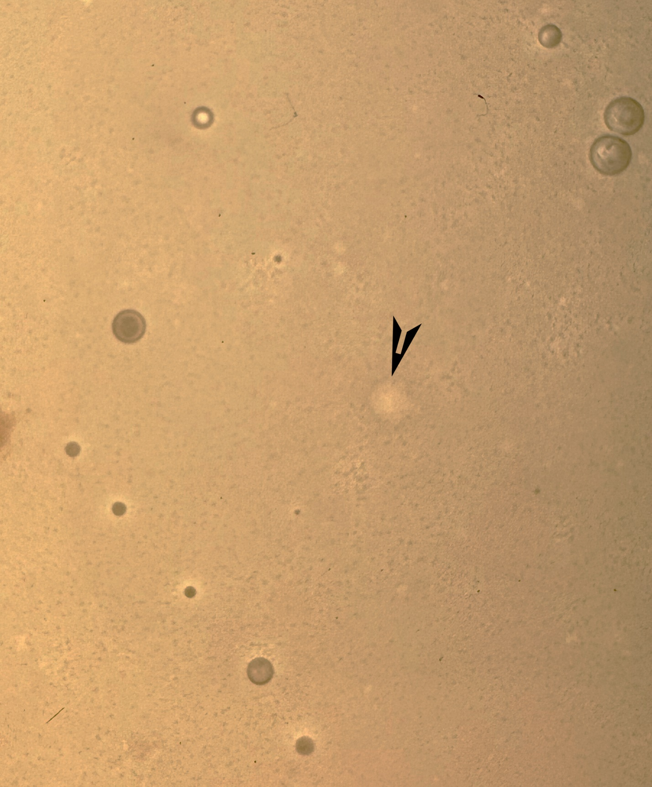
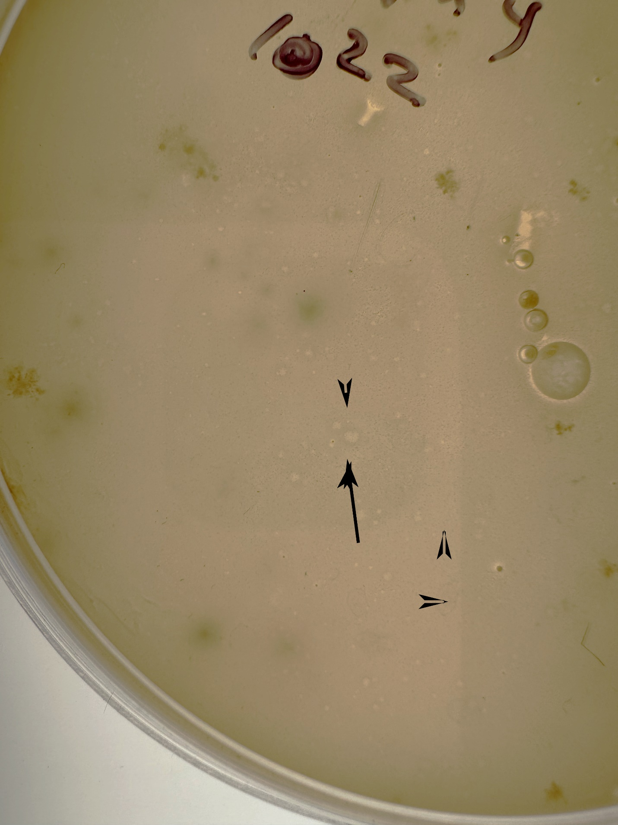

The negative control shows no plague.
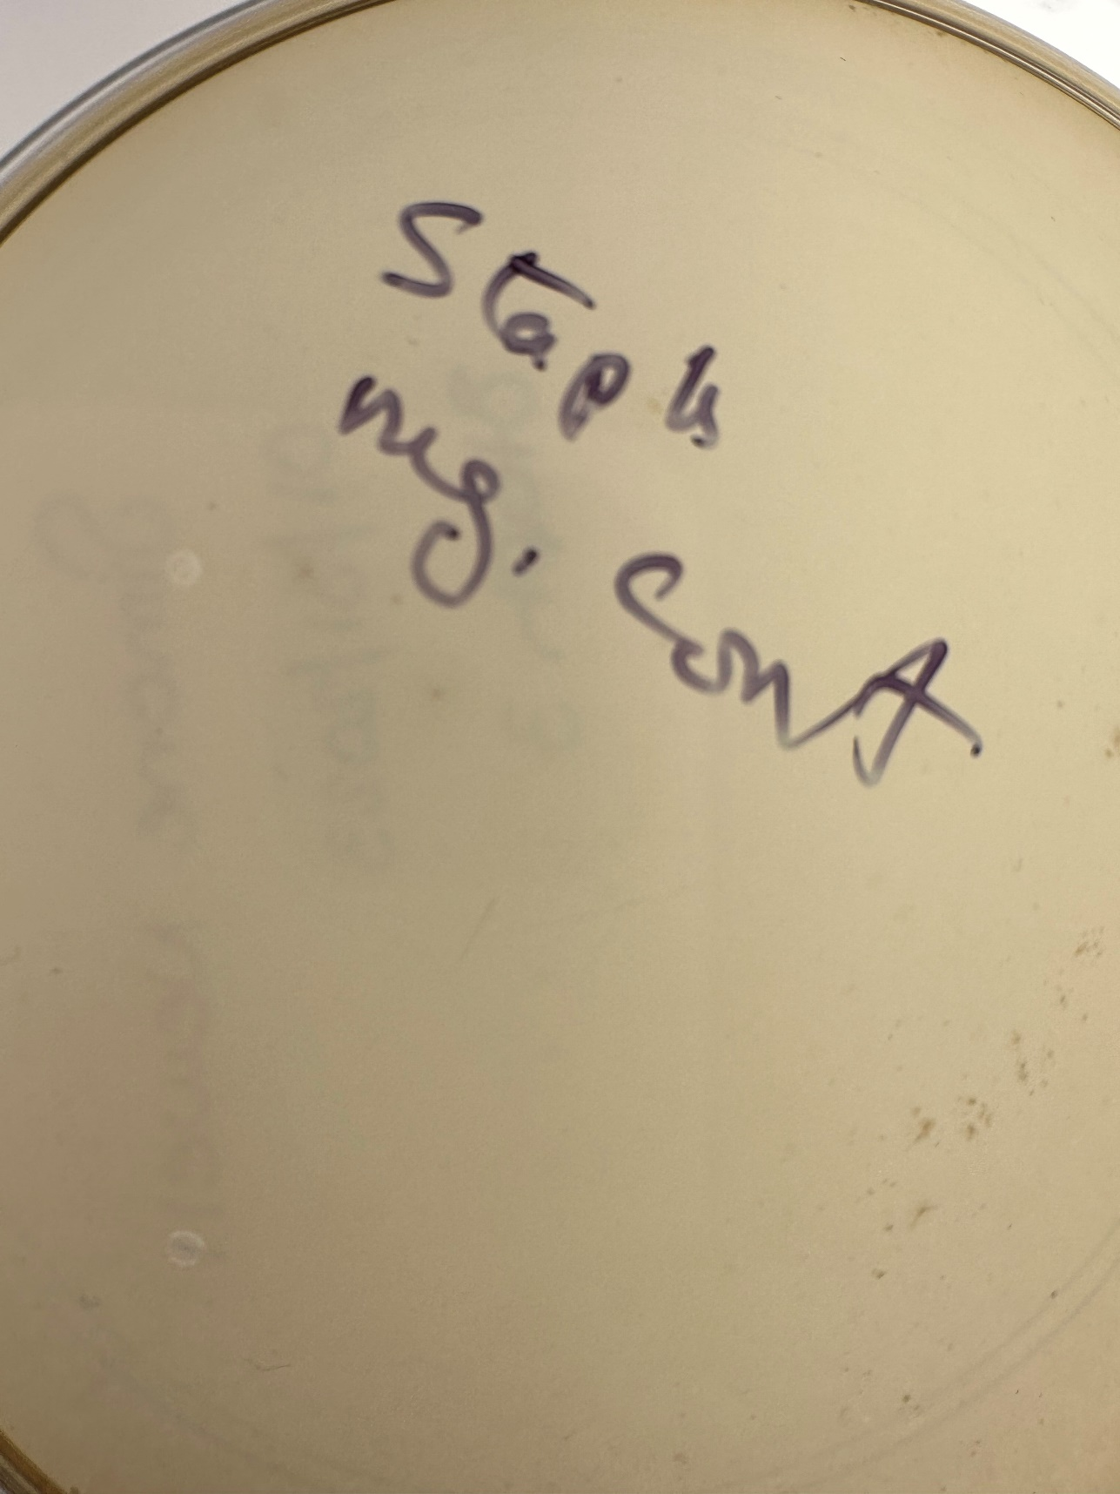

DISCUSSION

As previously stated, the idea of phage therapy has been around over the past 100 years. The successful use of phage therapy in the 1900s has shown that these types of procedures can effectively work and cure patients. Phage therapy was rediscovered in this experiment when a locally sourced bacteriophage was used against four stains of MRSA. We discovered bacteriophages that specifically could eliminate MRSA1-4 strains. In conclusion, this study shows that even though phage therapy may not completely replace antibiotics because of their relatively narrow specificity, they are still important additions to the list of tools that can be used against multiple drug resistant pathogens.

SUMMARY AND CONCLUSION

Antibiotics are still considered effective against some MRSA-related infections, and vancomycin and daptomycin are among the first chosen antibiotics. However, with the emergence of MDR MRSA, alternative antimicrobials are urgently needed. The irrational use of antibiotics has affected not only humans but also the environment as we constantly interact with our surroundings. Bacteriphages serve as natural tools to lessen the deleterious impact of antibiotics and make up for the paucity of new effective antibiotics. Unlike antibiotics, phages are narrow and specific in action, are self-replicative, and are abundant in nature; hence, they can be easily isolated as and when required. However, care must be taken when using phages; for example, the preparation must be ultrapure, and the phages must contain no resistance/virulence genes or integrase genes because these genes could be transferred to commensal bacteria through transduction. Additionally, phage-encoded products are attractive tools for fighting and treating pathogenic S. aureus. A famous English proverb states that “An enemy’s enemy is a friend”. This is apt for bacterial viruses that can serve as weapons against pathogenic bacteria. The prospects for phages and phage-encoded products are very encouraging in using phages as therapeutics with respect to S. aureus- related infections.

REFERENCES

- Summers WC. 1999. Felix d’Herelle and the Origins of Molecular Biology. New Haven, CT: Yale Univ. Press
- Aiello AE, Larson EL, Sedlak R. 2008. The health revolution: medical and socioeconomic advances. AmJ. Infect. Control. 36:S116–27
- Chanishvili N. 2012. Phage therapy—history from Twort and d’Herelle through Soviet experience to current approaches. Adv. Virus Res. 83:3–40
- Kortright KE, Chan BK, Koff JL, Turner PE. 2019. Phage therapy: a renewed approach to combat antibiotic-resistant bacteria. Cell Host Microbe 25:219–32.
- Lowy FD (1998) Staphylococcus aureus infections. N Engl J Med 339(8):520–532. https://doi.org/10.1056/NEJM199808203390806
- Williams REO (1963) Healthy carriage of Staphylococcus aureus: its prevalence and importance. Bacteriol Rev 27(1):56
- Wertheim HF, Melles DC, Vos MC, Van Leeuwen W, Van Belkum A, Verbrugh HA, Nouwen JL (2005) The role of nasal carriage in Staphylococcus aureus infections. Lancet Infect Dis 5(12):751– 762.
- Taylor TA, Unakal CG (2020) Staphylococcus aureus. [Updated 2020 Aug 23]. In: StatPearls. StatPearls Publishing, Treasure Island (FL). Available from: https://www.ncbi.nlm.nih.gov/books/ NBK441868/
- Wilde AD, Snyder DJ, Putnam NE, Valentino MD, Hammer ND, Lonergan ZR et al (2015) Bacterial hypoxic responses revealed as critical determinants of the host-pathogen outcome by TnSeq analysis of Staphylococcus aureus invasive infection. PLoS Pat- hog 11(12):e1005341. https://doi.org/10.1371/journal.ppat.10053 41
- Foster T (1996) Staphylococcus. In: Baron S (ed) Medical Micro- biology, 4th edn. The University of Texas Medical Branch, Gal- veston, pp 187–197
- McGuinness WA, Malachowa N, DeLeo FR (2017) Focus: infec- tious diseases: vancomycin-resistance in Staphylococcus aureus. Yale J Biol Med 90(2):269–281.
- Pantosti A, Sanchini A, Monaco M (2007) Mechanisms of anti- biotic resistance in Staphylococcus aureus. Future Microbiol 2:323–334. https://doi.org/10.2217/17460913.2.3.323

