The impact of the circadian gene, Bmal1, on regulators of blood pressure and sodium excretion

By

BRANDON T. SANDERS

A Thesis Submitted in Partial Fulfillment of the Requirements for the
Degree of Master of Biotechnology in the
Department of Biology, School of Natural Sciences and Mathematics

Claflin University
Orangeburg, South Carolina
May 2022

M. Kamal Chowdhury Steffani Driggins
Dr. Steffani Driggins
Committee Member
Dr. Kamal Chowdhury
Thesis Advisor

 M. Kamal Chowdhury
_____________________
Dr. Shrikant Pawar
Committee Member
Dr. Kamal Chowdhury
Academic Advisor

Received by: _____________________________________ Date: ______________

Dr. Gloria S McCutcheon, Chair, Department of Biology

Received by: _____________________________________ Date: ______________

Dr. Verlie Tisdale, Acting Dean, School of Natural Sciences and Mathematics

Received by: _____________________________________ Date: ______________

Dr. Verlie Tisdale, Interim Vice Provost for Academic Affairs
ACKNOWLEDGEMENTS

I would like to express my sincere gratitude to a few people without whom this thesis would not have been possible. These individuals provided support and guidance during preparation and completion of this study.
I would like to thank my principal advisor Dr. Kamal Choudhury for his continuous support and guidance for my research. This study would not have been possible without his guidance and invaluable support. I would like to thank my thesis committee for their unwavering encouragement. I would also like to thank the members of the David Pollock Lab at the University of Alabama at Birmingham (UAB) School of Medicine for hosting me and helping me conduct the wet lab portion of my project.
I would like to acknowledge the financial, academic, and technical support of Claflin University and its staff. I would like to thank the Department of Biology for their financial support and assistance. Also, I would like to acknowledge the financial support of the KURE program at UAB which is a National Institutes of Health funded Summer Research IMG 20210607 095459616 HDR Program.
I would also like to thank my parents and my family for their continued love and support. This thesis is in memory of my late grandmother, Sheila D. Sanders, who wanted nothing more than to see me walk across the stage. I love you and miss you so much, but I know that you are smiling down on me.

TABLE OF CONTENTS

Acknowledgments…………………………………………………………………………i
Table of Contents………………………………………………………………………….ii
Abstract……………………………………………………………………………………1
Introduction………………………………………………………………………………..2
Literature Review………………………………………………………………………….6
Materials and Methods…………………………………………………………………….9
Results…………………………………………………………………………………….18
Conclusion………………………………………………………………………………...29
References…………………………………………………………………………………31

ABSTRACT

High salt intake, which is prevalent in Western diets, has been shown to disrupt the renal molecular clock, which can contribute to adverse health outcomes such as hypertension and organ failure. One of the factors involved in the maintenance of the renal molecular clock and kidney function is Bmal1, a core clock gene and transcription factor. Bmal1 has been shown to contribute to the activity of sodium channels and transporters along renal tubules. However, the effect of Bmal1 on genes that regulate sodium homeostasis such as endothelin-1 (ET-1), in the context of a high salt diet remains unknown. We hypothesized that increased sodium intake would increase the expression of ET-1 that is dependent upon Bmal1. Bmal1 knockout (KO) and wild type (WT) rats were placed into metabolic cages and fed a normal (0.4%) or high (4%) salt diet. The kidneys and urine of these animals were collected to determine ET-1 concentration, nitrite production, and excretion of sodium and ET-1. This study also includes an in depth look at Bmal1 using bioinformatic tools to analyze the conservation of the gene across different species.

INTRODUCTION

Blood pressure (BP) is the force of blood while being circulated through the arteries. Each time that the heart beats, blood is pumped throughout the body pushing against the arterial walls. Systolic pressure (SP) is the pressure exerted against the walls when the heart beats and typically when BP is at its highest. In healthy adults, systolic blood pressure (SBP) is found to be 120 mmHg or lower. Diastolic pressure (DP) is the pressure that is left when the heart relaxes. Blood pressure is normally represented by a ratio of the SP and the DP, respectively 120/80 being the standard pressure. High blood pressure (HBP), often referred to hypertension, is a condition where SP is consistently high in the systemic arteries. The most common cause for the onset of HBP is a diet that consists of high dietary salt. In several studies, the excess consumption of sodium has been seen to have a positive correlation with a multitude of adverse health conditions including HBP (Malta et. al, 2018). HBP is a common risk factor that can lead to a multitude of different health conditions including diseases affecting the renal system (Oparil et. al, 2019).
Under normal conditions, the kidney is richly perfused accounting for about 25% of cardiac output using autoregulation (Carlstrom et. al, 2015). The kidney governs plasma osmolality by balancing the amount of water, solutes, and electrolytes to achieve homeostasis. The kidney does this by dictating what will be reabsorbed into the blood and what will be excreted which affects the blood pressure. This process occurs throughout the day following a diurnal pattern of increasing and decreasing blood pressure (BP) during specific times of day. In healthy individuals, BP has been shown to decrease approximately 10-20% lower during the nighttime as opposed to daytime. This is referred to as “nocturnal BP dipping.” This kidney phenomenon is amongst several processes within the body that are maintained by internal clocks which creates what is known as circadian rhythms.
Circadian rhythm is a biological process exhibited by all life forms where different bodily functions and/or behaviors reoccur within a 24-hour period or cycle. In humans, as well as other animals, there are specific rhythms within a single 24-hour day displayed amongst multiple organ systems, the kidney being one of them. These reoccurring actions can be dictated by both extrinsic and intrinsic stimuli including photic exposure, nutrition consumption, as well as gene expression known as “clock genes” (Kwon et. al, 2011). The mammalian circadian clock system is separated into three components including input signals, output signals, and a circadian oscillator. Light detected by the eyes is transported to the suprachiasmatic nucleus (SCN) through the retinohypothalamic tract. The SCN has been identified as a master circadian oscillator because it generates circadian rhythmicity using different neural and hormonal signals. This rhythmicity is converted into output pathways known as peripheral clocks that controls different behaviors, physiologies, and metabolism. Many clock genes have been identified within the kidney that are responsible for maintaining the circadian pattern even in the absence of external cues. The disturbance of circadian rhythms contributes to a multitude of pathological states. Aryl hydrocarbon receptor nuclear translocator-protein, also known as Bmal1, is one of two major genes that has been characterized to drive rhythmic gene expression.
Together, the major circadian genes circadian locomotor output cycles kaput (CLOCK) and Bmal1 form a transcription-translation loop. Bmal1 is referred to as a component of the core clock due to its ability to stimulate transcription of a wide variety of circadian target genes by binding to the promoter regions after heterodimerization including period (Per) and cryptochrome (Cry) (Zhang and Pollock, 2018). After Per and Cry are transcribed, they translocate into the nucleus to inhibit the expression of CLOCK and Bmal1. After going through a multistep phosphorylation, gene expression of Bmal1 and CLOCK will continue. Bmal1, along with CLOCK, is said to be a part of the positive arm of the core clock due to this interaction. Evidence has shown that Bmal1 could be involved in the maintenance of renal function. With a global knock out (KO) of the Bmal1 gene, it has been seen that organisms have a complete loss of circadian rhythmicity in activity, feeding, sleeping, and BP. Within the kidney, Bmal1 KO studies have shown that with the depletion of Bmal1 affects blood pressure phenotypes as well as renal electrolyte excretion. The diurnal pattern of the excretion of urinary sodium follows a trend of the active period of rats being the higher as compared to the inactive period. Rats being nocturnal, excretion is expected to be higher at night than in the daytime. In a previous experiment, it was seen that rats kept their diurnal pattern of sodium excretion when Bmal1 was silenced, but in male rats the pattern of sodium excretion was reversed. The inactive period was seen to have higher levels of sodium secretion as compared to the usual active period. Another thing that was seen was that in both genders of Bmal1 knock out rats, the maintenance of arterial pressure followed its expected pattern of having a higher pressure during the active period than the inactive period. However, the overall pressure was seen to be significantly lower in females but only slightly lower in male rats (Johnston et al., 2020).
In another study, rats were fed a high salt diet to see if the diet would impair Bmal1 function through an endothelin 1 (ET-1) dependent mechanism. High salt has been seen to stimulate renal ET-1 and activate the ET_{B} receptor which inhibits sodium reabsorption. Under high salt conditions ET-1 excretion patterns were maintained having higher excretion during the active period than the inactive period but there was an increase in the amount ET-1 present in the urine. Also, under high salt conditions, there was an increase in the amount of Bmal1 mRNA present in the inner medulla during the inactive period (Speed et al., 2018). With the information previously observed, the objective of this study is to evaluate the relationship between Bmal1 and sodium homeostasis in a context of a high salt diet. This study will also focus on characterization of Bmal1 using bioinformatic tools.

LITERATURE REVIEW
It is well established that nighttime blood pressure (BP) is typically 10-20% lower than it is during the daytime. This phenomenon has been termed “BP dipping.” Some studies have suggested that the reduction or the inversion of the BP dipping in some subjects is associated with high sodium intake and salt sensitivity (Bankir et al., 2008). The absence of this phenotype has been linked to organ damage in patients as well as a prognostic marker for the morbidity and mortality of cardiovascular disease. Research has also shown that disruptions in circadian renal function control can contribute to hypertension and kidney disease (Zhang and Pollock, 2018).
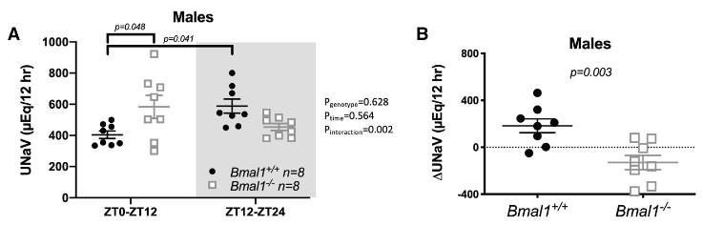
Bmal1 has been identified as a core regulator of the molecular clock. Many studies have been conducted to observe the role of the clock gene in relation to kidney function under normal and high salt (HS) conditions. In a previous study, it was attempted to determine the role Bmal1in the circadian control of BP and Na+ excretion in rats (Johnston et al., 2020). Under normal salt conditions, when Bmal1 was genetically silenced, the diurnal pattern of urinary salt excretion was reversed, and the overall excretion was reduced but this was only seen in male rats (Figure 1).
Figure 1. A Diurnal pattern of urinary Na+ excretion (UNaV) in male Bmal1+/+ and Bmal -/- rats. Shaded area represents the 12-h active period where lights are off. Two-way ANOVA was used for statistical analysis with post hoc results indicated when statistically significant. B Show active minus inactive period differences in Na+ in male rats. ZT indicates zeitgeber.

However, it was seen that the diurnal pattern of BP was maintained even in the absence of Bmal1, but the average blood pressure was lower (Figure 2).
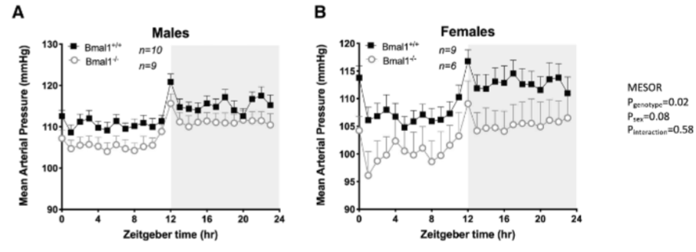
Figure 2 Twenty-four hour mean arterial pressure for male (A) and females (B) rats measured by telemetry in Bmal1+/+ and Bmal -/- rats. Data were collected over three consecutive 24-h periods. Two-way ANOVA results for mesor are indicated.

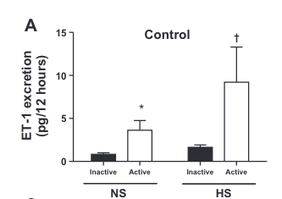
In another study conducted, they sought to test the hypothesis that HS intake impairs Bmal1 function through an ET-1-dependent mechanism to facilitate Na+ excretion and maintain long-term balance (Speed et al., 2017). It was seen that under the HS conditions, ET-1 excretion maintained its diurnal pattern where that excretion was higher in the active period than the inactive period. More so, what was observed was the amount of ET-1 excretion was increased (Figure 3).
Figure 3 12-h urinary ET-1 excretion (pg/12h) in rats fed either normal salt or high salt diet for two weeks.

It was also observed that under a high salt diet, the kidney clocks Bmal1 and Clock were desynchronized via ET_{B} receptors (Figure 4). With information shown it is well observed that high
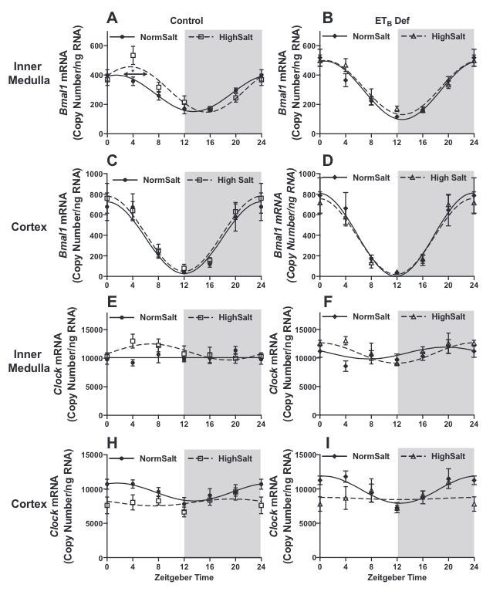
Figure 4 mRNA expression (copy count) in 4-h intervals of renal medullary Bmal1 (A) renal cortical Bmal1 (C) renal inner medullary Clock (E), and renal cortical Clock (H) of control rats that have been maintained on normal or high salt diet for two weeks. Symbols represent means ±SE, and lines represent cosinor analysis. *P < 0.05 for acrophase.

salt does have an effect on the kidney clock genes which leads to the question of what roles does the Bmal1 gene play under these HS conditions and how it may maintain sodium homeostasis? The goal of this study is to analyze this relationship.

MATERIALS and METHODS

Animals
Experiments were performed using male Bmal1KO (Bmal1^{−/−}) rats created on a Sprague Dawley (SD) genetic background and their littermate controls (Bmal1^{+/+}) obtained from the in-house breeding colony at the University of Alabama at Birmingham. These rats were created using Clustered regularly interspaced short palindromic repeats (CRISPR)/CRISPR-associated (Cas9) nuclease protein gene targeting technology with the help of the Gene Editing Rat Resource Center at the Medical College of Wisconsin. In our rat model, plasmids harboring 3 CRISPRs sgRNAs targeting the sequences (ggccccaccgacctgctctc, gactgcaaccgcaagaggaa, and gtccacaccactggtgctca) and expressing Cas9 were injected into the embryos of SD rats (Crl:SD, Charles River Laboratories). A founder animal harboring a 58 base pair deletion in exon 6 (first coding exon) of the Bmal1 gene was identified and confirmed by DNA sequencing. This founder was back crossed to the parental SD strain and colony of heterozygous breeders with the 58-bp mutation was established. To mitigate the effects of potential off-target mutational effects of CRISPR engineering and to maintain the outbred background of the model, a new SD breeder is introduced by back crossing into the colony at each generation. Otherwise, all breeding is conducted with male and female heterozygous rats. The deletion is predicted to cause a premature stop codon in exon 6 resulting in a severe truncation of the Bmal1 protein. To genotype, tail snip genomic DNA was extracted (Extracta DNA prep from QuantaBio, Beverly, MA), and polymerase chain reaction run using AccuSTart II PCR genotyping kit (QuantaBio) with the following primers (5’ to 3’): F1 GGAAACCTCATGCTTCCACAGGCA; R1 ACAATGCGGTTGTGGGCAGG. Control (+/+) rats have an amplicon of 333 base pairs (bp) while Bmal1 mutant (−/−) rats have an amplicon of 275 bp.
Animals were housed under conditions of constant temperature and humidity with a 12:12 hour light-dark cycle and maintained on standard rodent chow (Envigo 7917 Irradiated NIH-31 Open Formula Mouse/Rat Sterilizable Diet, 0.3% Na⁺ and 0.6% K⁺) until they were moved to the metabolic cages. Experimental protocols and animal care methods were approved by both the Medical College of Wisconsin and University of Alabama at Birmingham Institutional Animal Care and Use Committees in accordance with the National Institutes of Health Guide for the Care and Use of Laboratory Animals (Johnston et al., 2020).
Metabolic Cage and Urine Collection
Metabolic cages were used to collect the urine of the rats to analyze the effects of a high salt diet comparing Bmal1 KO rats to WT rats (Fig 1). Before changing the diets to high salt (4% NaCl), rats were allowed 3-5 days to acclimate to the metabolic cages on normal diets (0.4% NaCl). Rats were also given one water bottle with 80mL of water from a hydro pack. After 24hrs, the collection tubes (food, urine, and water) and the rats were weighed and recorded. Urine was collected for further analysis using 50mL tubes and labeled indicating the cage the sample was collected from as well as the day of collection (i.e., Sample 1, Day 3).
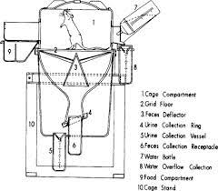
Figure 1. Example of metabolic cage used for urine collection (Koch, 2006)
On the last day of the acclimation period after all measurements are taken and the urine from the previous 24hrs is collected, the rats are then placed on the high salt diet for at least a week. Once the high salt diet begins, the urine was collected every 12hrs to separate urine collected during the active and inactive periods of the rats. Other measurements such as the food and water collection tubes are also analyzed within the 12hr periods. On the last day of collection, after the urine is collected and all measurements are taken, the kidneys are harvested for tissue analysis.

Tissue Collection and Treatment
Rats were anesthetized with 2% to 3% isoflurane to excise the kidneys which were later decapsulated and cut longitudinally. Next, the kidneys were dissected into 3 sections (cortex, outer, and inner medulla) and placed into Hanks' Balanced Salt Solution (HBSS) after being manually homogenized and placed in 1.5mL Eppendorf tubes on ice. Homogenization was done by rotating the tissue on a glass slide 90º clockwise four times for one full 360º turn. The number of turns done and the amount of HBSS added was determined by the section the tissue originated from (Table 1). After all samples were collected and labeled, the tubes were centrifuged for 5 min at 4ºC 1000xg. Next, the supernatant was removed, and the tissue was treated with a dose curve of ET-1 (Vehicle, 100nM, 200nM, and 400nM) containing HBSS, L-Arginine, and superoxide dismutase (SOD) and was incubated for 90 minutes in a 37ºC shaking water bath. After incubation, the tubes were centrifuged again at 4ºC 1000xg until the tissue formed a pellet. The supernatant was transferred to a separate 1.5mL Eppendorf tube for analysis. Both the supernatant and the tissue were snap-frozen in liquid nitrogen and stored at −80° (Figure 2).

 | HBSS on ice | # of 360º turns
Cortex | 500uL | 6x
Inner Medulla (IM) | 1000uL | 8x
Outer Medulla | 1000uL | 8x
Table 1. HBSS volume and homogenization instructions for each kidney section
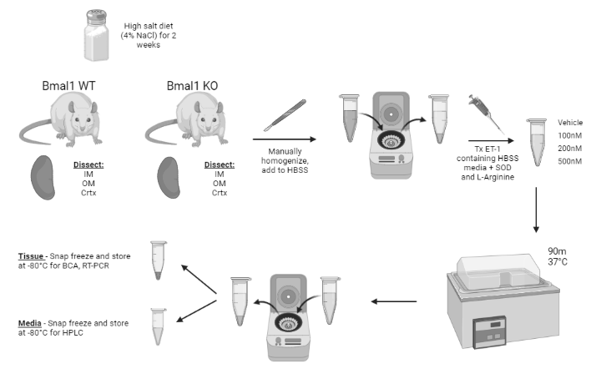
Figure 2. Tissue treatment protocol
Bradford Protein Assay
To prepare the standards a 1mg/ml of bovine serum albumin (BSA) standard was made by adding 10mL of distilled water to 10mg of BSA. Then in separate tube, 500uL of 1mg/mL BSA standard into 500uL of distilled water. This process of serial dilution was continued to produce standards of .25mg/mL, .125mg/mL, and .065mg/mL by adding 500uL of distilled water to 500uL of the standards being made. To create a standard curve, all standards as well as distilled water were performed in triplicates adding 5uL of each to three wells.
ET-1 treated kidney tissue was homogenized and 5uL of diluted sample was added to the wells in triplicates. Then, 250uL of BioRad Quickstart Reagent solution was added to each BSA standard and sample. The plate was then covered and placed on a shaker for 5 minutes. Then the plates were read using the Epoch microplate reader (wavelength 595nm).
ELISA
Before the reagent can be prepared, all reagents must be brought to room temperature. To prepare the 1000mL of wash buffer, 100mL of wash buffer concentrate is added to 900mL of deionized or distilled water. To make the working Glo reagent, 4mL of Glo Reagent A and 8mL of Glo Reagent B in a capped plastic container and protected from light 15min to 4hrs before use. 100uL of the working Glo reagent was required for each well. To make the ET-1 standard curve, a 2500pg/mL stock solution was produced by reconstituting the standard with deionized or distilled water and allowed to rest for a minimum of 15min with gentle agitation prior to serial dilution. 900uL of Calibrator Diluent RD5-13 was pipetted into the 250pg/mL tube and 600uLwas pipetted into the remaining tubes. The sock solution was used to produce a 3-fold dilution series (250pg/mL, 83.3pg/mL, 27.8pg/mL, 9.26pg/mL, 3.09pg/mL, 1.03pg/mL, 0.343pg/mL) and were mixed thoroughly changing the pipette tips between each transfer.
After all reagents and working standards were prepared, the excess microplate strips were removed from the plate frame. 100uL of Assay Diluent RD1-19 was added to each well then 100uL of standard, control, and urine samples were added in duplicates to their respective wells and covered using the adhesive strip provided in the kit. The plate was then incubated for 1.5hrs at room temperature on a horizontal orbital microplate shaker set at 500$±$50rpm. Each well is then aspirated and washed, repeating the process three times (four total washes) using 400uL of wash buffer using a squirt bottle completely removing the liquid at each step. After the last wash, all remaining wash buffer was removed by blotting the plate against clean paper towels. 200uL of the Human ET-1 conjugate was added to each well and then covered with a new adhesive strip. The plate was then incubated for 3hrs on the shaker at room temperature. After the wash and aspiration step was repeated for a total of four washes, 100uL of working Glo reagent was added to each well and incubated for 5-20 minutes at room temperature on the benchtop protected from light. The relative light units (RLU) of each well were determined using a luminometer set to following parameters: 1.0min lag time; 0.5 sec/well-read time; summation mode; auto gain on, or equivalent.
HPLC
Homogenized rat renal inner medulla tissue samples were placed in an ice-cold lysis buffer (150mM NaCl, 1mM EDTA, 1mM EGTA, 0.5% Triton x-100 and 20mM TrisHCl; pH 7.5) in the presence of protease inhibitors (1mM PMSF, 1uM leupeptin, 1uM pepstatin A, and 1uM aprotinin). Homogenates were centrifuged at 1,000g for 5 minutes to remove cellular debris, and the supernatant protein concentrations were determined by Bradford assay and then heated with 6x Laemmli buffer and 5% β-mercaptoethanol for 10min at 60ºC.
Before running the HPLC, the following buffers were prepared. A Carrier buffer was made by mixing 1L of 10% methanol and 1 bottle of Carrier Buffer Powder. The Reactor Buffer was made of equal parts of Reactors A and Reactor B. Reactor A was made by mixing 500mL of 10% methanol, 1 bottle of Reactor A Powder, and 12.5mL of HCl. Reactor B was made by mixing 500mL of 10% methanol, 1 bottle of and Reactor B Powder. Each buffer was vortexed until no crystals or bubbles remained in the bottle and allowed to come to room temperature.
The precolumn was repacked using an acetone suspended packing gel. The gel and precolumn filter were then removed using a tip and cleaned on both ends with 200uL of acetone and wiping with a Kimwipe. A precolumn filter was placed in the larger side and pressed in with the back of a tip. Next, a syringe was hooked up to the smaller side and the gel suspension was added with a 200uL pipet. Also, a syringe was used to pull out the acetone until the gel had trned white and was dry. This was repeated until there was a mound present.
To prepare the ENO-30, 11 mL of Carrier Buffer was removed for the standard curve. The tubes were then inserted into the carrier and reactor bottles and ran pumps for 5min at 300uL/min turning Pump A on first. Next, the right side of the precolumn was connected with the arrow pointing left on the machine. Once Pump A was running, the fluid was allowed to run to ensure proper flow is maintained through the precolumn. Then, the other end of the precolumn was connected and was placed in the second column and was ran for 30 minutes. To create the standard curve, carrier buffer was put into each tube (Table 2). 10uL of 100mmol stock was added to S, then 400uL of S was added to the 4000 solution, 500uL of the 4000 solution was added to 2000 solution, and 500uL of the 2000 solution was added to the 1000 solution. Then 1:10 dilutions were made.
Standard | Amount of Carrier Buffer (uL)
S | 990
.4-400 | 900
4000 | 600
1000-2000 | 500
Table 2. Volumes of carrier buffer for standard curve
Conical bottom 96 well plates were used plating 150uL of sample per well. The plate was ended with a small standard curve (CB, 1, 10, 100). Samples were then covered with an adhesive plate cover and marked to indicate the orientation of the plate. Once the plate is loaded the computer program was ran. After the results were collected, the standard curve was copied and pasted and 10uL of standards and 20uL of samples was injected. The pump flow rate was set to 330uL/min for Pump A and 100uL for Pump B. To complete the run, the pumps were stopped (Pump B first) and the columns were removed. The wash buffers were set to 500uL/min for 30 minutes and then the samples were removed.

Quantifying RNA with Nano Drop
Renal tissue (50–100mg) was homogenized in trizol reagent, and RNA was extracted according to manufacturer’s instructions (ThermoFisher Corp, Waltham, MA). Reverse transcription was carried out with 1μg of DNase-treated RNA using the iScript Reverse Transcription kit BioRad cDNA synthesis kit (Product no. 1708891, BioRad Laboratories, Hercules, CA). Next, gene expression was carried out by digital droplet PCR. The digital droplet PCR reaction was set up using ddPCR probes Supermix, 1uL of TaqMan primer/probes, and cDNA from 50ng of total RNA. The reaction mix was separated into nanodroplets using the automated droplet generator (BioRad). The cDNA made was snap-frozen in liquid nitrogen and stored at −80°. PCR was carried out for 40 cycles per manufacturer’s instructions. Droplets were counted using the QX200 Droplet Reader and data was analyzed, and copy count calculated using Quanta Soft software (Johnston et al., 2020).

RT-qPCR
The TaqMan Fast Advanced Master Mix was thoroughly mixed while the cDNA and frozen TaqMan Assays were allowed to thaw on ice. The master mix was made for a 96-well plate and mixed gently by adding 10uL of TaqMan Fast Advanced Master Mix [2x], 1uL of TaqMan Assay primmer/probe [20x], and 7uL of nuclease free water. 18uL of the master mix was added to each well. Then, 2uL of cDNA was added to each well and was ran in triplicates. The run was set so that it the sample was held at 50ºC for 2 minutes, then 95ºC for 20 seconds, then 95ºC for 3 seconds, and lastly 60ºC for 30 seconds.

NCBI BLAST
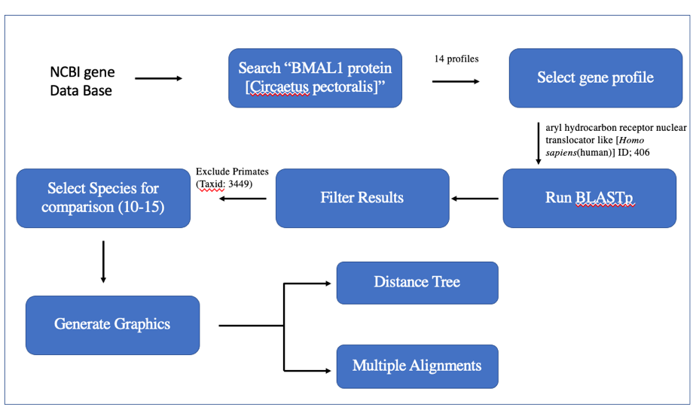
The National Center of Biotechnology Information (NCBI) is a leading source for public biomedical databases, software tools for analyzing molecular and genomic data, and research in computational biology. In this study, the basic local alignment search tool (BLAST) was used to find different organisms that have a similar genetic makeup to Homo sapiens and observe how conserved the Bmal1 gene is across different species. To begin, using the search tool in NCBI, the Bmal1 protein was searched and the ARNTL (humans) with the gene ID 406 was selected as the reference gene to find the accension number to run the BLAST. Using the accension number BAA19936.1, the BLAST was ran using the protein function (BLASTp). Amongst the species generated, 14 species were selected with varying identical percentages. Again, the BLASTp was ran, this time using the function to compare different proteins placing BAA19936.1 in the main window, and the accension numbers of the 14 species selected in the comparison window. Once the BLASTp has been ran, different graphics were generated to display the alignment differences as well as a phylogenic tree (Figure 3).

Figure 3. NCBI BLASTp protocol

RESULTS
RT-PCR
RT-PCR was used to evaluate the expression of Edn1, which is a known gene regulated by circadian clock genes, using three Bmal1 KO model rats normalized to three Bmal1 WT model rats all placed on normal salt diets (0.4% NaCl) collecting tissue at set Zeitgeiber Times (ZT) with a total of 18 KO rats and 18 WT rats. Fold changes were performed by collecting the quantification of Edn1 gene expression (Cq value) and utilizing the Delta-Delta-Ct algorithm (Figure 4). At ZT 0, the WT rats had an average Cq value of 34.35 and the KO rats had an average Cq value of 32.11 with an average fold change of 5.25. At ZT 4, the WT rats had an average Cq value of 35.84 and the KO rats had an average Cq value of 36.76 with an average fold change of 3.53. At ZT 8, the WT rats had an average Cq value of 37.33 and the KO rats had an average Cq value of 36.83 with an average fold change of 1.19. At ZT 12, the WT rats had an average Cq value of 36.06 and the KO rats had an average Cq value of 36.33 with an average fold change of 0.06. At ZT 16, the WT rats had an average Cq value of 35.59 and the KO rats had an average Cq valueof 35.83 with an average fold change of 0.23. Lastly, at ZT 20, the WT rats had an average Cq value of 33.12 and the KO rats had an average Cq value of 31.93 with an average fold change of 0.52. It was observed that Edn1 expression was upregulated in KO rats during their inactive period as compared to WT rats. The next phase of this 24-hr tissue collection is to repeat the procedures using high salt diets (4% NaCl) to observe the difference in Edn1 expression between Bmal1 WT and KO rats.
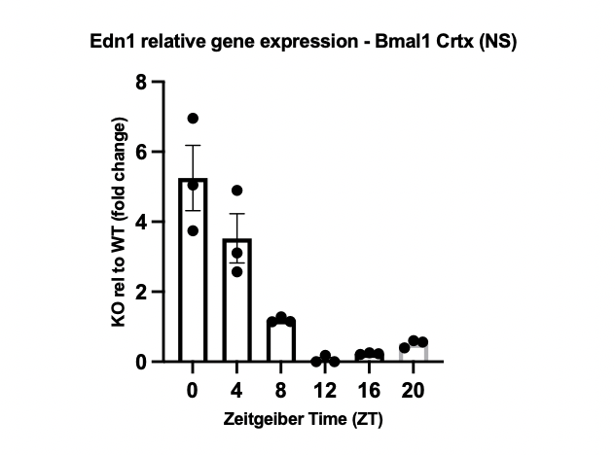
Figure 4. RT-PCR quantification of Edn1 in the Ctx of Bmal1 KO rats normalized to Bmal1WT rats. Diurnal expression of Edn1was inverted in KO rats.

ELISA
ET-1 excretion was examined comparing the urine of three Bmal1 KO and three WT rats on HS diets collected in a 12hr span using ELISA testing for analysis (Figure 5). In the Bmal1 WT model the average day-time ET-1 excretion was 108.99pg/12hr and the average nighttime ET-1 excretion was 156.74pg/12hr. In the Bmal1 KO model the average day-time ET-1 excretion was 71.51pg/12hr and the average nighttime ET-1 excretion was 70.25pg/12hr. It was observed that ET-1 excretion was significantly reduced in the KO rats both in comparison to WT rats during the day and nighttime collection periods (12hrs). Also, the difference between day and nighttime collection was no longer observed in the KO rats but in the WT rats, there was a significant difference. Further testing will be performed using a larger sample size.
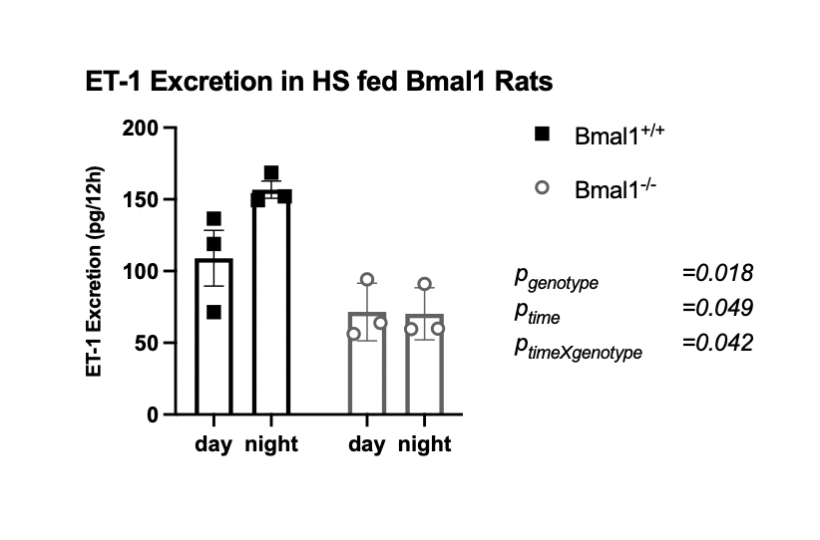
Figure 5. ELISA analysis of HS fed WT and KO rat urine collected 12hr apart. Lower overall ET-1 excretion was seen in the KO rat. Diurnal excretion was absent in KO rats.
HPLC
Nitrite levels were observed using HPLC to examine the different sections of the kidney. Sections of the kidney (inner medulla (IM), outer medulla (OM), and cortex (Ctx)) of one Bmal1 KO rat and one WT rat were treated with different concentrations of ET-1 (100nM, 200nM, and 500nM) and was compared to the correlating sections that were treated with a vehicle (Figure 6). In the IM, the WT presented a negative fold change of -57.80 pmol/mg pr/hr, a positive fold change of 130.58 pmol/mg pr/hr, and a positive fold change of 83.41 pmol/mg pr/hr respectively. Within the IM of the KO model, displayed was a positive fold change of 22.21 pmol/mg pr/hr, a negative fold change of -8.71 pmol/mg pr/hr, and a positive fold change of 23.35 pmol/mg pr/hr respectively. These readings were inconsistent and did not have a clear trend present. Within the OM, the WT presented a positive fold change of 147.30 pmol/mg pr/hr, a negative fold change of -41.81 pmol/mg pr/hr, and a negative fold change of 37.04 pmol/mg pr/hr respectively. In outer medulla, Within the OM of the KO model, displayed was a negative fold change of -10.34 pmol/mg pr/hr, a positive fold change of 4.90 pmol/mg pr/hr, and a positive fold change of 432.12 pmol/mg pr/hr. There was no clear trend within the WT model however within the KO model in the OM the expression of nitrite increased along with the concentration of the ET-1 treatment increased. Within the Ctx of the WT model, displayed was positive fold change of 135.47 pmol/mg pr/hr, a positive fold change of 116.11 pmol/mg pr/hr, and a positive fold change of 27.84 pmol/mg pr/hr respectively. Within the Ctx of the KO model, displayed was a positive fold change of 16.38 pmol/mg pr/hr, a positive fold change of 59.05, and a positive fold change of 12.80. There was a clear trend within the WT model within the Ctx that as the concentration of ET-1 increased the amount of nitrite decreased. However, in the KO model there weas no clear trend. For further analysis, a larger sample size would be required to provide better statistical significance.
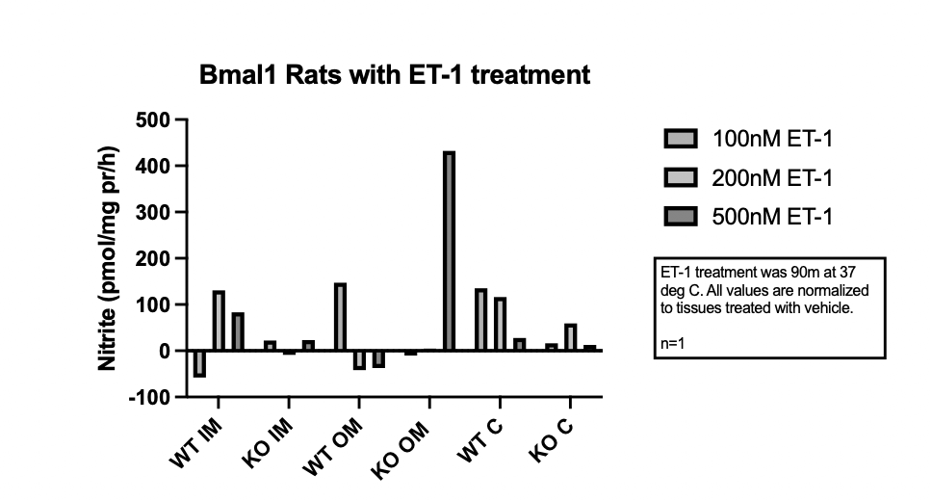
Figure 6. Nitrite levels of kidney tissue treated with ET-1normalized to vehicle

Bradford Protein Assay
Nitrite levels of kidney tissue (IM, OM, and Ctx) were examined utilizing one Bmal1 KO and one Bmal1 WT rat on a HS diet using a Bradford Protein Assay. Kidney sections were treated with different concentrations of ET-1 (Vehicle, 100nM, 200nM, and 500nM) and were analyzed using an Epoch microplate reader to record light absorbance. The light absorbance observed correlates with the amount of protein present (Figure 7). Within the IM of the WT rat, the vehicle treated tissue had a scan rate of .42mVs. Treated IM tissue had scan rates of .36mVS, .33mVs, and .38mVs respectively. Compared to the vehicle, treated samples had lower concentrations of nitrite but there was no trend observed as ET-1 concentration increased (Figure 7). Within the IM of the KO rat, the vehicle treated tissue had a scan rate of .39mVs. Treated IM tissue had scan rates of .47mVS, .43mVs, and .342mVs respectively (7A). Compared to the vehicle, treated IM tissue from the KO rat had a higher concentration of nitrite. Within the OM of the WT rat, the vehicle treated tissue had a scan rate of .26mVs (7B). Treated WT OM tissue had scan rates of .41mVS, .50mVs, and .45mVs respectively. Compared to the vehicle, treated OM tissue of the WT had increased concentrations of nitrite. However, in the KO OM tissue, the scan rates of the 100nM ET-1 and 500nM ET-1 treated tissue were downregulated compared to the vehicle. Within the OM of the KO rat, the vehicle treated tissue had a scan rate of .51mVs. Treated OM tissue had scan rates of .35mVS, .53mVs, and .17mVs respectively. In the Ctx of the WT rat, there was an unclear trend of Nitrite presence (7C). Within the Ctx of the WT rat, the vehicle treated tissue had a scan rate of .89mVs. Treated Ctx tissue had scan rates of .67mVS, 106.mVs, and 1.06mVs respectively. In the KO Ctx tissue, all ET-1 treatment concentrations were upregulated compared to the vehicle. Within the Ctx of the KO rat, the vehicle treated tissue had a scan rate of .24mVs. Treated IM tissue had scan rates of .84mVS, .76mVs, and .82mVs respectively. This analysis is set to be reran with a larger sample size.

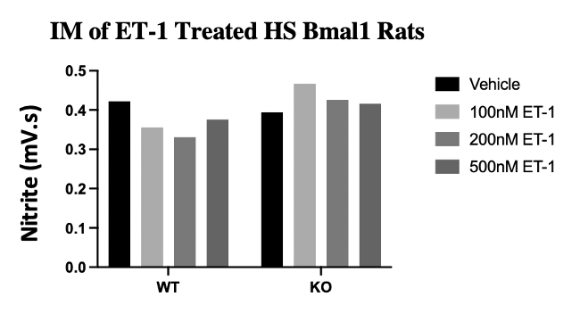

B

A
√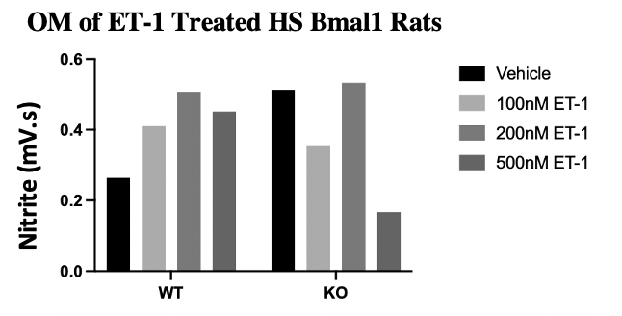

C
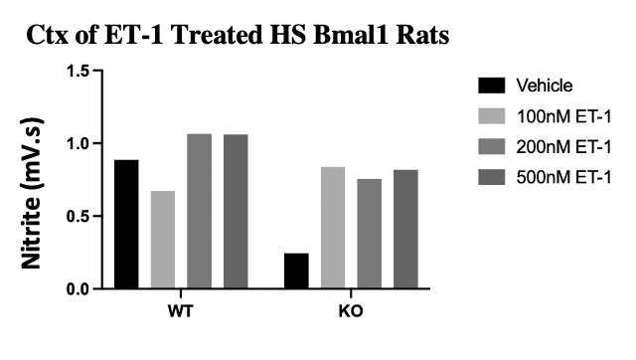
Figure 7. Nitrite levels of ET-1 treated Bmal1 KO and WT rats on high salt diets (4% NaCl). The IM (A), OM (B) and the Ctx (C) were the tissues being treated.

NCBI BLAST
The NCBI BLAST tool was used to examine the conservation of the Bmal1 gene across different species. Using the Aryl hydrocarbon receptor nuclear translocator-like (Arntl) protein accession number, a BLAST was generated showing different species with similar sequences. From that list, a shorter list was compiled using 13 species with varying percentage identities ranging from 100-98.81% (Table 3). The percentage identitiy refers to the amount of a sequence is identical to a reference. The animals with the highest percentage identity to the Homo sapiens’ Arntl protein sequence were the bats one being an Egyptian fruit bat and the other was the black flying fox which both had a 100% percentage identity. These species were also used to generate a phylogenic tree to observe the distance of relation. The Egyptian fruit bat and the black flying fox were the closest to Homo sapiens which may correlate to the high percentage number. However, the higher the percentage identity doesn’t necessarily correlate with closeness in relation. The horse was seen to have a percentage identity of 99.3% but was closer than other species such as the grey squirrel or the American beaver which both have percentage identities of 99.66%. Further analysis was doon comparing the species’ proteins sequences using query anchored alignments to observe the conservation of the amino acid sequences. The dots shown in the sequences refers to amino acids that are identical to the Homo sapiens’ sequence. In instances of a mismatch, the one letter code of the amino acid that isn’t identical to the Homo sapiens’ sequence is shown. Within the query range of 120-250, there were high levels of matches. Also in query section 481-580, most species had a similar characteristic. All species featured on the list were members of the class Mammalia which may account for the high percentage. In future searches, excluding this class may be helpful in obtaining more distant relatives to the Homo sapiens.

Table 3. Species selected for BLAST analysis

Figure 8. Phylogenic Tree generated from Blast
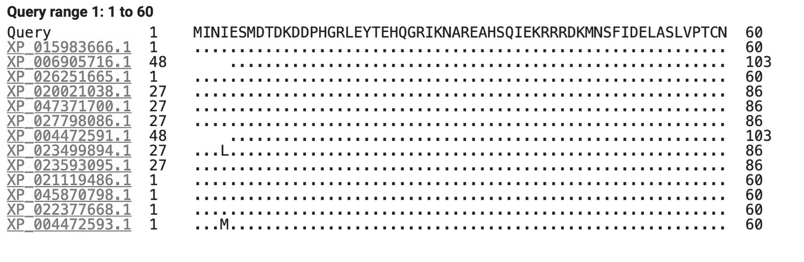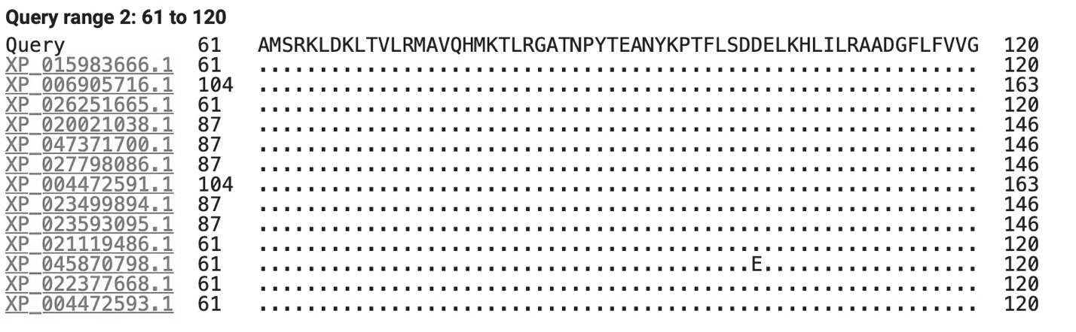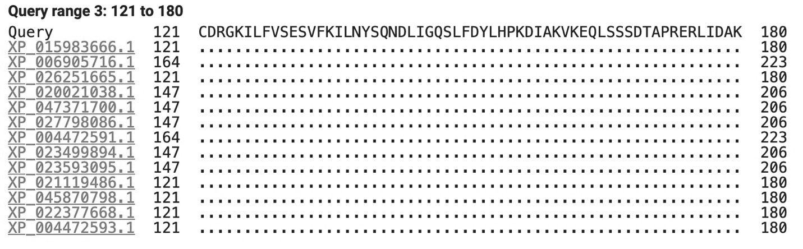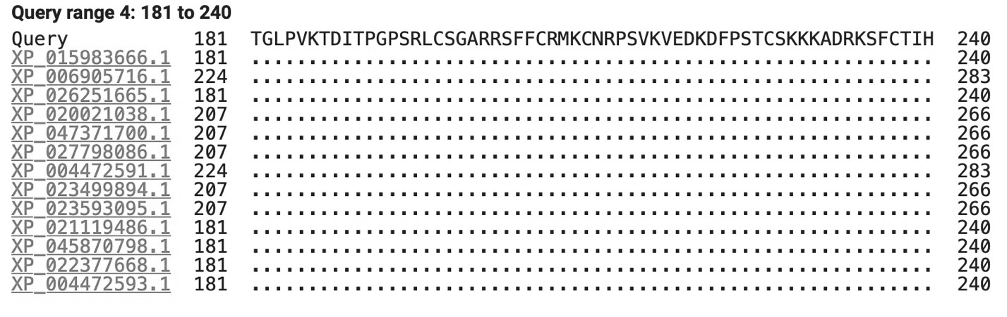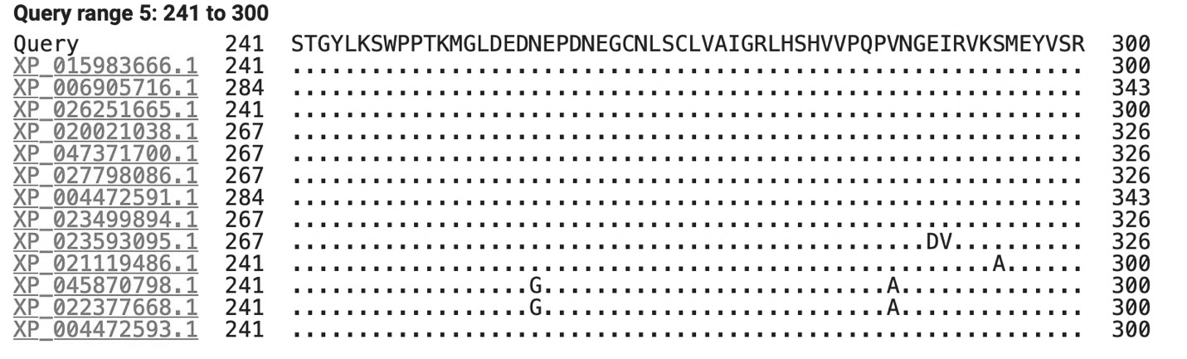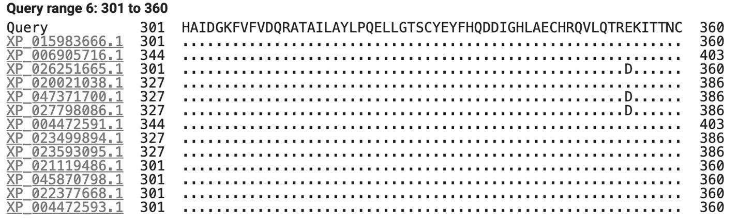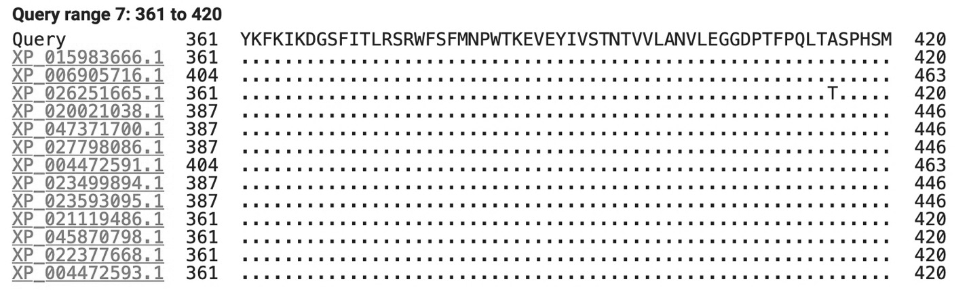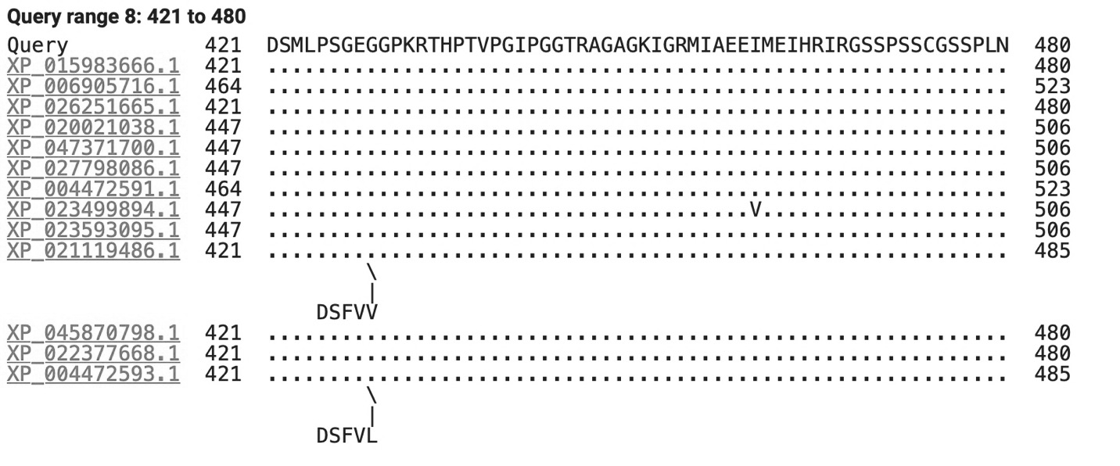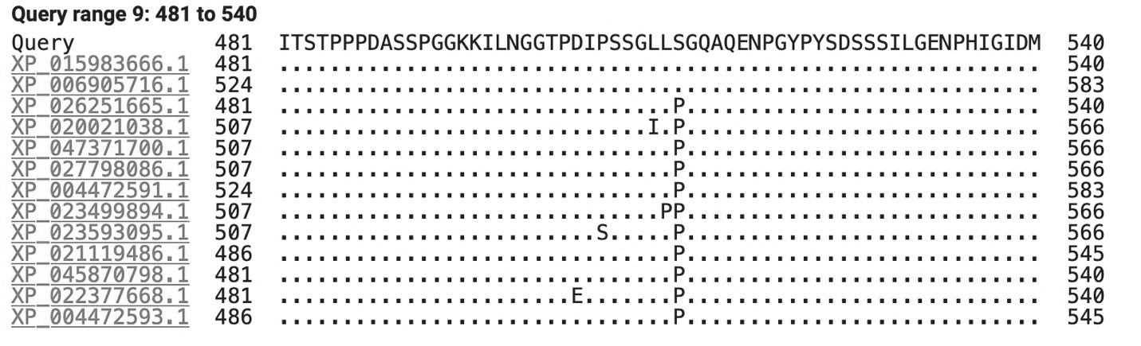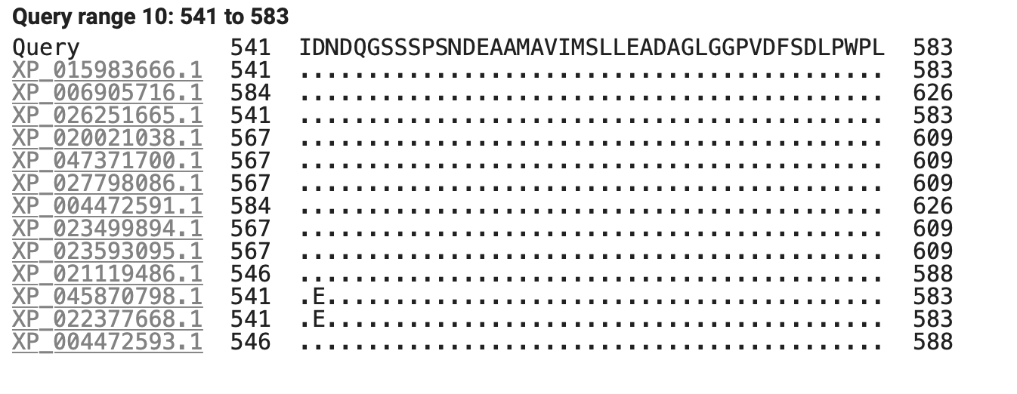
Figure 9. Anchored based query of Homo sapiens compared to the selected species.

Conclusion and Future Directions
RT-PCR confirmed that Bmal1 regulates the circadian expression of Edn1. The expression of Edn1 in KO rats was completely reversed compared to the WT rats. The KO rats had a higher expression during their inactive period than in their active period. In the next stage of this experiment, the expression of the Edn1 gene as well as other genes known to be regulated by Bmal1will be observed under a high salt diet (4%) in WT and KO Bmal1 rats. The ELISA test performed was used to compare the daytime and nighttime excretion of ET-1. In the absence of Bmal1, daytime and nighttime ET-1 excretion levels remained fairly similar throughout the day rather than diurnally.
HPLC was ran to analyze the nitrite levels in the sections of the kidney. The presence of nitrite did not follow a particular trend with the ladder treatment of ET-1. While continuing this study, it is recommended that the treatment time of kidney tissue in ET-1 be increased. Also, the experiment will be repeated with a larger sample size to improve the statistical significance. A Bradford Assay was also used to analyze the nitrite levels within the tissue. Nitrite levels were downregulated in ET-1 treated WT IM tissue, but the KO IM tissue had an upregulation in comparison to vehicle treatment. In the OM, nitrite expression was higher in WT treated tissue than its control sampled but the KO tissue did not have an observable trend. In the Ctx of the ET-1 treated tissue of the WT, there wasn’t a trend present in nitrite levels. However, the KO Ctx had upregulation of nitrite levels in each section of the kidney compared to the vehicle. In future portions of this, a larger sample size will be used to obtain more statistically significant data.
The BLAST ran showcased that Bmal1 protein is highly conserved amongst several species. However, the species pulled from the BLAST were all mammals. For further analysis, it is pertinent to use model species from varying classes to increase the diversity of the search. A future step for the experiment is to run assays for the expression of additional genes associated with blood pressure regulation and sodium excretion using high salt fed WT and KO Bmal1 rats. Different genes of interest include endothelial sodium channel gamma (ENaC𝛾), angiotensin II (AngII), renin, nitric oxide synthase 1 (NOS1), an aldosterone. For the bioinformatics portion of the experiment, GEO datasets will be used to gene map various diseases related to kidney function such as chronic kidney disease, hypertension, and circadian misalignment. Also, an in-depth analysis of the structure of the Bmal1 will be done to understand more about functions and behavior of the protein. Some sources error may include constant unthawing of tissue.

REFERENCES

Bankir L, Bochud M, Maillard M, Bovet P, Gabriel A, and Burnier M. Nighttime blood pressure and nocturnal dipping are assoiciated with daytime urnary sodium excretion in African subjects. 2008. Hypertension 51:891-898. doi: 10.1161/HYPERTENSIONAHA.107.105510.
Carlstrom M, Wilcox CS, and Arendshorst WJ. Renal autoregulation in health and disease. 2015. Physiology Review. 95: 405-511. doi: 10.1152/physrev.00042.2012.
Ishimoto Y, Tanaka T, Yoshida Y, and Inagi R. Physiological and pathophysiological role of reactive oxygen species and reactive nitrogen species in the kidney. 2018. Clinical and Experimental Pharmacology and Physiology 45: 1097-1105. doi:10.1111/1440-1681.13018.
Johnston JG, Speed JS, Becker BK, Kasztan M, Soliman RH, Rhoads MK, Tao Binli, Jin C, Geurts AM, Hyndman KA, Poolock JS, and Pollock DM. Diurnal control of blood pressure is uncoupled from sodium excretion. 2020. Hypertension 75: 1624-1634. doi: 10.1161/HYPERTENSIONAHA.119.13908.
Kwon I, Choe HK, Son GH, and Kim K. Mammalian molecular clocks. 2011. Eperimental Neurobiology 20: 18-28. doi: 10.5607/en.2011.20.1.18.
Lee J, Bae EH, Ma SK, Kim SW. Altered Nitric oxide system in cardiovascular and renal diseases. 2016. Chonnam Medical Journal 52: 81-90. doi: 4068/cmj.2016.52.2.81.
Prokkola JM and Nikinmaa M. Circadian rhythmsand environmental disturbances- underexplored interactions. 2018. Journal of Experimental Biology 221. doi:10.1242/jeb.179267.
Malta D, Peterson KS, Johnson C, Trieu K, Rae S, Jefferson K, Santos JA, Campbell NRC, and Arcand J. 2018. The World Hypertension League 20: 1654-1665. doi: 10.1111/jch.13408.
Murata Y, Ueono T, Tanaka S, Kobayashi H, Okamura M, Hemmi S, Fuke Y, Matsumoto Y, Abe M, and Fukuda Noboru. Identification of clock genes related to hypertension in kidney from spontaneously hypertensive rats. 2020. American Journal of Hypertension 33 (12): doi:10.1093/ajh/hpaa123.
Oparil S, Acelajado MC, Bakris GL, Berlowitz DR, Cifkova R, Dominiczak AF, Grassi G, Jordan J, Poulter NR, Rodger A, and Whelton PK. Hypertension. 2019. Nat Rev Dis Primers 4: 18014. doi:10.1038/nrdp.2018.14.
Speed JS, Hyndman KA, Roth K, Heimlich JB, Kasztan M, Fox BM, Johnston JG, Becker BK, Jin C, Gamble KL, Young ME, Pollock JS, and Pollock DM. High dietary sodium causes dyssynchrony of the renal molecular clock in rats. 2018. American Journal of Physiology Renal Physiology 314: F89-F98. doi:10.1152/ajprenal.00028.2017.
Zhang D and Pollock DM. Circadian regulation of kidney function: finding a role for Bmal1. 2018. American Journal of Physiology Renal Physiology 314: F675–F678. doi:10.1152/ajprenal.00580.2017.

